FP2 English 20 Day Revision
Challenge

Exam dates:
Literature Paper 1: Monday 12th May 2025 (am)
Literature Paper 2: Tuesday 20th May 2025 (am)
Language Paper 1: Friday 23rd May 2025 (am)
Language Paper 2: Friday 6th June 2025 (am)



W&L: Mind map all of the poems that explore the theme of belonging from the anthology. Make a note of one quotation from each poem. | AIC: Evidence the differences between capitalism and socialism using key quotes from the play. | Macbeth: Explode three quotations that demonstrate the theme of violence within the play. | ACC: Mind map 5 key themes from the novella and detail two pieces of evidence for each one. | AIC: Create an essay plan for the following question:  How does Priestley present both Sheila and Mrs Birling as stubborn within the play?
Macbeth: Write one analytical paragraph that explores the relationship between Macbeth and Lady Macbeth. | ACC: Identify and explode three pieces of evidence that present Scrooge’s changing character. | W&L: Write a thesis paragraph that outlines your argument for the following question:  Explore how poets present the power of setting within ‘In a London Drawing Room’ and one other poem? | AIC: Create a character profile for Eva Smith/Daisy Renton, include textual references made by the other characters. | W&L: Create an essay plan for the follow question:  Explore how poets present the importance of identify within ‘Name Journeys’ and one other poem.
AIC: How does Priestley present the theme of justice throughout the play?  Write one analytical paragraph based on evidence from the end of the play. | ACC: Identify and explode three pieces of evidence that present redemption as a key theme. | Macbeth: Explode three quotations that demonstrate the theme of ‘duplicity’ within the play.  Write a thesis paragraph that addresses the question: How does Shakespeare present the theme of duplicity? | W&L: Mind map all of the poems that explore the theme of nature from the anthology. Make a note of one quotation from each poem. | ACC: Create an essay plan for the following question:  How does Stevenson present the relationship between Scrooge and the rest of society?
Macbeth: Explode three quotations that demonstrate the theme of loyalty within the play. Remember that you may also consider disloyalty when doing so! | W&L:  Identify which two poems you feel the least confident with. Create a knowledge organiser that includes:  -A summary of the poem  -Three key quotations  -On structural point  -One key contextual idea | AIC:  List as many stage directions as you can recall from the play. Make a note of one interpretation for each piece of evidence. | ACC: List as many textual references as you can recall for the theme of family. Write a thesis paragraph that explores the presentation of this theme. | Macbeth: Create an essay plan for the following question:  How does Shakespeare present the theme of kingship?
AIC: Create a thesis paragraph that explores the presentation of Mr. Birling’s character throughout the play. Continue this and write one analytical that explores his response the Inspector’s revelation. | W&L: Create an essay plan that explores the theme of place within ‘The Jewellery Maker’ and one other poem. | ACC: Answer the following question:  How does Dickens present the ghosts as powerful characters? | W&L: Answer the following question: Explore how poets present the theme of education within ‘Thirteen’ and one other poem. | Macbeth: List and analyse three pieces of evidence per theme listed below:  -Guilt  -Manipulation  -Supernatural
Create a knowledge organiser that details our class structures for each question on paper 1.  (15 minutes) | Create a knowledge organiser that details our class structures for each question on paper 2.  (15 minutes) | Create a cue card of language devices a writer can use. Include definitions and examples (15 minutes) | Read question 2 for mini mock 1. Pick 3 quotations which you could use to answer. Write an answer for question 2. Time yourself. (10 minutes) | Reread mini mock 1. Find evidence the mother is angry and upset in lines 12-32. Explode your evidence. (10 minutes)  Complete an answer for question 4. Time yourself. (25 minutes)
Mind map key vocabulary for the picture in mini mock 1. Use a thesaurus. (5 minutes) | Write a descriptive piece for the image. Use the DROP, ZOOM, SHIFT, ZOOM structure. (45 minutes)  Check your punctuation. Have you used the following: , . ! ; ( )  Add them in correctly to create impact. (10 minutes) | Look around you, write down 5 adjectives. Mind map as many alternatives as you can. (10 minutes) | Read the ending of a fiction book of choice. Or the end of a chapter. Consider how it ends and why? (10 minutes) | Read the opening of a fiction book of choice. Consider how it begins and why? (10 minutes)
Read the paper 2 mini mock 2 on ‘gender equality’. Highlight how the women are described in each. (10 minutes) | Answer question 1 for mini mock 2, highlighting the evidence for each. (5 minutes) | In source A of mini mock 2, what is Emma Watson campaigning for? Find evidence for this? (10 minutes) | Write an answer to mini mock 2 question 2. Use the POINT, EVIDENCE, INFERENCE, COMPARE structure. (10 minutes) | Highlight 3 ways each of the writers convey their attitudes towards gender. Quote explode them. (10 minutes)
Make a list of non-fiction devices that could be used in an argument, to persuade or to explain something. (10 minutes) | Read an article on line or in a newspaper. What was the article about? How did the writer get across their view? What are your thoughts on the topic? (10 minutes) | Write an answer to the following statement:  ‘Both men and women should feel free to be sensitive. Both men and women should feel free to be strong.’ Write an article in which you explain your point of view on this statement.  Use the ANECDOTE, RESEARCH, COUNTER ARGUMENT, RHEOTIRCAL CHALLENGE structure.(45minutes) | Use a whole page of A4 and write down as many non-fiction topics as you can that could be asked of you for GCSE paper 2 question 5. (10 minutes) | Make a note of things you have found difficult in English. Can you specifically tackle any of them? (10 minutes)
Read paper 1 mini mock 3. Highlight words to describe the man and his house. (10 minutes) | Reread mini mock 3 question 2. Pick 3 quotations which you could you to answer and explode them. (10 minutes)  Write an answer for question 2. Time yourself. (10 minutes) | Write down the side of the mini mock where the writer has used structural features. (10 minutes)  Write an answer for question 3. Time yourself. (10 minutes) | Based on your reading on mini mock 3, do you feel something unexpected is going to happen? Find evidence for and against. (10 minutes) | Write a descriptive piece for the image. Use the DROP, ZOOM, SHIFT, ZOOM structure. (30 minutes)  Reread your description. Edit and change any vocabulary you think you could improve. (10 minutes)
Read mini mock 4. Answer question 1 highlighting the evidence for each. (5 minutes) | Write an answer to question 2 paper 2. (10 minutes) | Highlight language used in source A to describe the surroundings. Quote explore key words. (10 minutes) | Highlight 3 ways each of the writers convey their attitudes towards disease. Quote explode them. (10 minutes) | What message are the writers giving in source A and B? Find evidence. (10 minutes)  Complete question 4. (20 minutes)
Extra Challenges: | Find a photo/ picture and mind map a plan to describe it. (10 minutes) | Read an article on line or in a newspaper. What was the article about? How did the writer get across their view? What are your thoughts on the topic? (10 minutes) | Plan an answer to the following statement:  “School uniforms stifle creativity and individuality.” Write a speech for your school assembly, stating whether or not you think school uniforms should be worn Write an article in which you explain your point of view on this statement. (10 minutes) | Write an answer to the following statement:  “School uniforms stifle creativity and individuality.” Write a speech for your school assembly, stating whether or not you think school uniforms should be worn Write an article in which you explain your point of view on this statement. (30 minutes)

Paper 1 mini mock 1: a vendetta
Source A: The opening of a short story called ‘A Vendetta’ by Guy de Maupassant.
The widow of Paolo Saverini lived alone with her son in a poor little house on the outskirts of Bonifacio. The town, built on an outjutting part of the mountain, in places even overhanging the sea, looks across the straits, full of sandbanks, towards the southernmost coast of Sardinia. Beneath it, on the other side and almost surrounding it, is a cleft in the cliff like an immense corridor which serves as a harbor, and along it the little Italian and Sardinian fishing boats come by a circuitous route between precipitous cliffs as far as the first houses, and every two weeks the old, wheezy steamer which makes the trip to Ajaccio.
On the white mountain the houses, massed together, makes an even whiter spot. They look like the nests of wild birds, clinging to this peak, overlooking this terrible passage, where vessels rarely venture. The wind, which blows uninterruptedly, has swept bare the forbidding coast; it drives through the narrow straits and lays waste both sides. The pale streaks of foam, clinging to the black rocks, whose countless peaks rise up out of the water, look like bits of rag floating and drifting on the surface of the sea.
The house of widow Saverini, clinging to the very edge of the precipice, looks out, through its three windows, over this wild and desolate picture.
She lived there alone, with her son Antonia and their dog "Semillante," a big, thin beast, with a long rough coat, of the sheep-dog breed. The young man took her with him when out hunting.
One night, after some kind of a quarrel, Antoine Saverini was treacherously stabbed by Nicolas Ravolati, who escaped the same evening to Sardinia.
When the old mother received the body of her child, which the neighbors had brought back to her, she did not cry, but she stayed there for a long time motionless, watching him. Then, stretching her wrinkled hand over the body, she promised him a vendetta. She did not wish anybody near her, and she shut herself up beside the body with the dog, which howled continuously, standing at the foot of the bed, her head stretched towards her master and her tail between her legs. She did not move any more than did the mother, who, now leaning over the body with a blank stare, was weeping silently and watching it.
The young man, lying on his back, dressed in his jacket of coarse cloth, torn at the chest, seemed to be asleep. But he had blood all over him; on his shirt, which had been torn off in order to administer the first aid; on his vest, on his trousers, on his face, on his hands. Clots of blood had hardened in his beard and in his hair.
His old mother began to talk to him. At the sound of this voice the dog quieted down.
"Never fear, my boy, my little baby, you shall be avenged. Sleep, sleep; you shall be avenged. Do you hear? It's your mother's promise! And she always keeps her word, your mother does, you know she does."
Slowly she leaned over him, pressing her cold lips to his dead ones.
Then Semillante began to howl again with a long, monotonous, penetrating, horrible howl.
The two of them, the woman and the dog, remained there until morning.
Antoine Saverini was buried the next day and soon his name ceased to be mentioned in Bonifacio.
He had neither brothers nor cousins. No man was there to carry on the vendetta. His mother, the old woman, alone pondered over it.
Questions:
Q1: Use lines 1-5. List four things you learn about the location the story is set in.
Q2: Use lines 6-11. How does the writer use language to describe the setting?
Q3: Use the whole source. How does the writer structure the text to interest you as a reader?
Q4: Use lines 12-32. A student said “The mother is presented as both upset and angry at the death, and the writer creates sympathy for her in this ending”
To what extent do you agree?
In your response, you could:
- write your own impressions about the characters
- evaluate how the writer has created these impressions
- support your opinions with references to the text.

Black and white image:
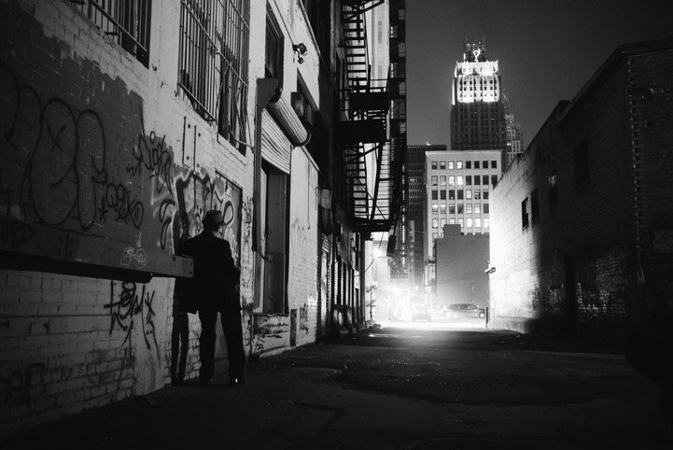

Paper 2 mini mock 2: gender
Source A: A transcript of Emma Watson’s speech to the UN in 2014 beginning the HeForShe Campaign.
Men, I would like to take this opportunity to extend your formal invitation. Gender equality is your issue, too. Because to date, I’ve seen my father’s role as a parent being valued less by society, despite my need of his presence as a child, as much as my mother’s. I’ve seen young men suffering from mental illness, unable to ask for help for fear it would make them less of a man. In fact, in the UK, suicide is the biggest killer of men between 20 to 49, eclipsing road accidents, cancer and coronary heart disease. I’ve seen men made fragile and insecure by a distorted sense of what constitutes male success. Men don’t have the benefits of equality, either.
We don’t often talk about men being imprisoned by gender stereotypes, but I can see that they are, and that when they are free, things will change for women as a natural consequence. If men don’t have to be aggressive in order to be accepted, women won’t feel compelled to be submissive. If men don’t have to control, women won’t have to be controlled.
Both men and women should feel free to be sensitive. Both men and women should feel free to be strong. It is time that we all perceive gender on a spectrum, instead of two sets of opposing ideals. If we stop defining each other by what we are not, and start defining ourselves by who we are, we can all be freer, and this is what HeForShe is about. It’s about freedom.
I want men to take up this mantle so that their daughters, sisters, and mothers can be free from prejudice, but also so that their sons have permission to be vulnerable and human too, reclaim those parts of themselves they abandoned, and in doing so, be a more true and complete version of themselves.
In my nervousness for this speech and in my moments of doubt I’ve told myself firmly: If not me, who? If not now, when? If you have similar doubts when opportunities are presented to you I hope that those words will be helpful, because the reality is that if we do nothing it will take 75 years, or for me to be nearly a hundred, before women can expect to be paid the same as men, for the same work. 15.5 million girls will be married in the next 16 years as children. And at current rates it won’t be until 2086 before all rural African girls can have a secondary education.
Source B: The following article from Punch, titled ‘The Best Sewing Machine’ is from 1859.
The very best Sewing-Machine a man can have is a Wife. It is one that requires but a kind word to set it in motion, rarely gets out of repair, makes but little noise, is seldom the cause of dust, and, once in motion, will go on uninterruptedly fox hours, without the slightest trimming, or the smallest personal supervision being necessary. It will make shirts, darn stockings, sew on buttons, mark pocket handkerchiefs, cut out pinafores, and manufacture children’s frocks out of any old thing you may give it; and this it will do behind your back just as well as before your face. In fact, you may leave the house for days, and it will go on working just the same. If it does get out of order a little, from being overworked, it mends itself by being left alone for a short time, after which it returns to its sewing with greater vigour than ever.
Of course, sewing machines vary a great deal. Some are much quicker than others. It depends in a vast measure upon the particular pattern you select. If you are fortunate in picking out the choicest pattern of a Wife-—one, for instance, that sings whilst working, and seems to be never so happy as when the husband’s linen is in hand—the Sewing Machine may be pronounced perfect of its kind; so much so, that there is no make-shift in the world that can possibly replace it, either for love or money. In short, no gentleman’s establishment is complete without one of these Sewing Machines in the house!
Q1: Which 4 statements are true:
- A woman’s role as a parent is less valued than a man’s role.
- HeForShe is about giving freedom back to women only.
- Watson wants men to support the HeforShe campaign.
- Watson sees gender as two sets of opposing stereotypes.
- Suicide is the biggest killer of men between 20 and 49.
- Watson believes that men don’t have equality, either.
- 15.5 million women will be married in the next 16 years.
- Watson feels both genders should be free to be sensitive.
Q2: Write a summary of the differences between the women described in each source.
Q3: In source A how does Emma Watson use language to persuade her audience?
Q4: Compare how the writers convey their attitudes to gender.
Paper 1 Mini-mock 3: the terrible old man
Source A: The opening of a short story called ‘The Terrible Old Man’ by H.P.Lovecraft (1920).
It was the design of Angelo Ricci and Joe Czanek and Manuel Silva to call on the Terrible Old Man. This old man dwells all alone in a very ancient house on Water Street near the sea, and is reputed to be both exceedingly rich and exceedingly feeble; which forms a situation very attractive to men of the profession of Mr. Ricci, Czanek, and Silva, for that profession was nothing less dignified than robbery.
The inhabitants of Kingsport say and think many things about the Terrible Old Man. He is, in truth, a very strange person, believed to have been a captain of East India clipper ships in his day; so old that no one can remember when he was young, and so taciturn that few know his real name. Among the gnarled trees in the front yard of his aged and neglected place he maintains a strange collection of large stones, oddly grouped and painted so that they resemble the idols in some obscure Eastern temple. This collection frightens away most of the small boys who love to taunt the Terrible Old Man about his long white hair and beard, or to break the small-paned windows of his dwelling with wicked missiles; but there are other things which frighten the older and more curious folk who sometimes steal up to the house to peer in through the dusty panes. These folk say that on a table in a bare room on the ground floor are many peculiar bottles, in each a small piece of lead suspended pendulum-wise from a string. And they say that the Terrible Old Man talks to these bottles, addressing them by such names as Jack, Scar-Face, Long Tom, Spanish Joe, Peters, and Mate Ellis.
Those who have watched the tall, lean, Terrible Old Man in these peculiar conversations, do not watch him again. But Angelo Ricci and Joe Czanek and Manuel Silva saw in the Terrible Old Man merely a tottering, almost helpless grey-beard, who could not walk without the aid of his knotted cane, and whose thin, weak hands shook pitifully. They were really quite sorry in their way for the lonely, unpopular old fellow, whom everybody shunned, and at whom all the dogs barked singularly. But business is business, and to a robber whose soul is in his profession, there is a lure and a challenge about a very old and very feeble man who has no account at the bank, and who pays for his few necessities at the village store with Spanish gold and silver minted two centuries ago.
Mr Ricci, Czanek, and Silva selected the night of April 11th for their call. Mr. Ricci and Mr. Silva were to interview the poor old gentleman, whilst Mr. Czanek waited for them and their presumable metallic burden with a covered motor-car in Ship Street, by the gate in the tall rear wall of their hosts grounds.
As prearranged, the three adventurers started out separately in order to prevent any evil-minded suspicions afterward. Mr Ricci and Mr Silva met in Water Street by the old man's front gate, and although they did not like the way the moon shone down upon the painted stones through the budding branches of the gnarled trees, they had more important things to think about than mere idle superstition. They feared it might be unpleasant work making the Terrible Old Man loquacious1 concerning his hoarded gold and silver, for aged sea-captains are notably stubborn. Still, he was very old and very feeble, and there were two visitors. Mr Ricci and Mr Silva were experienced in the art of making unwilling persons voluble2, and the screams of a weak and exceptionally venerable3 man can be easily muffled. So they moved up to the one lighted window and heard the Terrible Old Man talking childishly to his bottles with pendulums. Then they donned masks and knocked politely at the weather-stained oaken door.
1 – loquacious: talkative, chatty. 2 – venerable: respected, honoured
Q1: Use lines 1-4. List four things you learn about the ‘Terrible Old Man’.
Q2: Using lines 5-14. How does the writer use language to the ‘Terrible Old Man’ and his house?
Q3: Use the whole source. How does the writer structure the text to interest you as a reader?
Q4: Use lines 14 to End. A student said “Although the robbers seem like villains and the old man is the victim, it feels like something unexpected is going to happen.”
To what extent do you agree?
In your response, you could:
- write your own impressions about the characters
- evaluate how the writer has created these impressions
- support your opinions with references to the text.
Mini- Mock Writing:
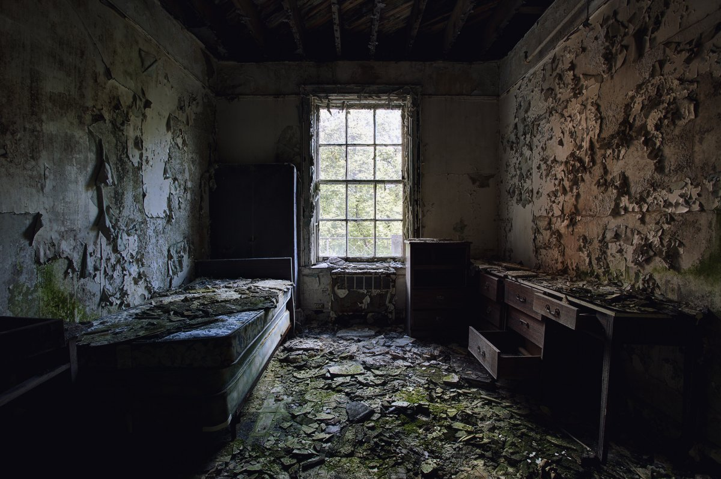

Paper 2 mini mock 4
Source A: An article from The Morning Chronicle from 1849 titled ‘Cholera District’
We then journeyed on to London-street, down which the tidal ditch continues its course. In No. 1 of this street the cholera first appeared seventeen years ago, and spread up it with fearful virulence; but this year it appeared at the opposite end, and ran down it with like severity. As we passed along the reeking banks of the sewer the sun shone upon a narrow slip of the water. In the bright light it appeared the colour of strong green tea, and positively looked as solid as black marble in the shadow - indeed it was more like watery mud than muddy water; and yet we were assured this was the only water the wretched inhabitants had to drink. As we gazed in horror at it, we saw drains and sewers emptying their filthy contents into it; we saw a whole tier of doorless privies in the open road, common to men and women, built over it; we heard bucket after bucket of filth splash into it, and the limbs of the vagrant boys bathing in it seemed, by pure force of contrast, white as Parian marble. And yet, as we stood doubting the fearful statement, we saw a little child, from one of the galleries opposite, lower a tin can with a rope to fill a large bucket that stood beside her. In each of the balconies that hung over the stream the self-same tub was to be seen in which the inhabitants put the mucky liquid to stand, so that they may, after it has rested for a day or two, skim the fluid from the solid particles of filth, pollution, and disease. As the little thing dangled her tin cup as gently as possible into the stream, a bucket of night-soil was poured down from the next gallery.
In this wretched place we were taken to a house where an infant lay dead of the cholera. We asked if they really did drink the water? The answer was, "They were obliged to drink the ditch, without they could beg a pailfull or thieve a pailfull of water. But have you spoken to your landlord about having it laid on for you? "Yes, sir; and he says he'll do it, and do it, but we know him better than to believe him." "Why, sir," cried another woman, who had shot out from an adjoining room, "he won't even give us a little whitewash, though we tell him we'll willingly do the work ourselves: and look here, sir," she added, "all the tiles have fallen off, and the rain pours in wholesale."
Source B: Nashon Tado reports on Cholera for the Norwegian Refugee Council in 2018.
Violence has forced thousands of Congolese to seek safety in neighbouring Uganda, with overcrowded refugee camps there putting pressure on hygiene and sanitation facilities, increasing the risk of deadly cholera outbreaks. Violence in the Democratic Republic of the Congo (DR Congo) has forced nearly 44,000 people to cross Uganda’s south-west border out of the country so far this year. This has put pressure on sanitation facilities in refugee settlements, and has led to deadly cholera outbreaks.
With hundreds of people arriving in Uganda every day, aid organisations are striving to prevent the disease from spreading across the settlements. Our teams work around the clock building hygiene and sanitation facilities to help alleviate and prevent the suffering of these displaced people.
Désiré is among the thousands who has been forced to adapt to a new life in Maratatu settlement in south-west Uganda. “There are people everywhere in the settlement. It’s a big risk in terms of the spreading of cholera. Something should be done to ease the congestion,” he says.
Those who have made it to Uganda now face this new life-threatening situation. Désiré worries about the conditions he and his fellow arrivals face in the packed settlement as a threat to public health: “With so many people crowded in one location, the risk of spreading of contagious diseases such as cholera is very high, and many people can be severely affected within a short time.” Meanwhile, hygiene and sanitation facilities in Kagoma transit centre, where newly arrived refugees are registered, also struggle to bear the brunt of overcrowding.
Q1:
- The refugees are seeking safety from Uganda.
- 44,000 refugees have crossed the border this year.
- The refugees have brought cholera with them.
- The refugee camps are becoming overcrowded.
- Désiré believes the refugee camps should be helped.
- The cholera outbreaks can kill people in the camp.
- The volunteers are doing nothing to improve hygiene.
- They have left their home country to seek new jobs.
Q2: Write a summary of the differences between the people described in each source.
Q3: In source A how does the writer use language to describe his surroundings?
Q4: Compare how the writers convey their attitudes to disease and sanitation in each source.

