FIELDWORK BOOKLET


Investigation Title:
To what extent does environmental quality improve with distance from the visitor centre at Coombe Abbey Park?
Human Geography Fieldwork

Study Sites: Coombe Abbey Park
Location of Coombe Abbey Park
Coombe Abbey Park is located to the East of Coventry, in Binley. The Park is a 500 acre park with a hotel, an adventure ‘Go Ape’ course, a visitor centre and a café. The park is also used for events such as creators markets and food festivals.
Why is it a suitable location?
Coombe Abbey is a suitable location due to its close proximity to school, being only 15 minutes by coach. It is accessible due to being located just off the A46 and has a large car park and several footpaths throughout. It was also a suitable location due to the economic activity in the park, and the large visitor centre which brings in and the large hotel for tourists. This allows us to see the environmental impact of visitors on the park in these areas of economic activity.
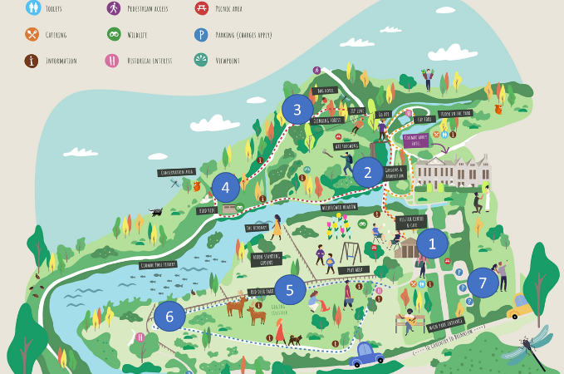
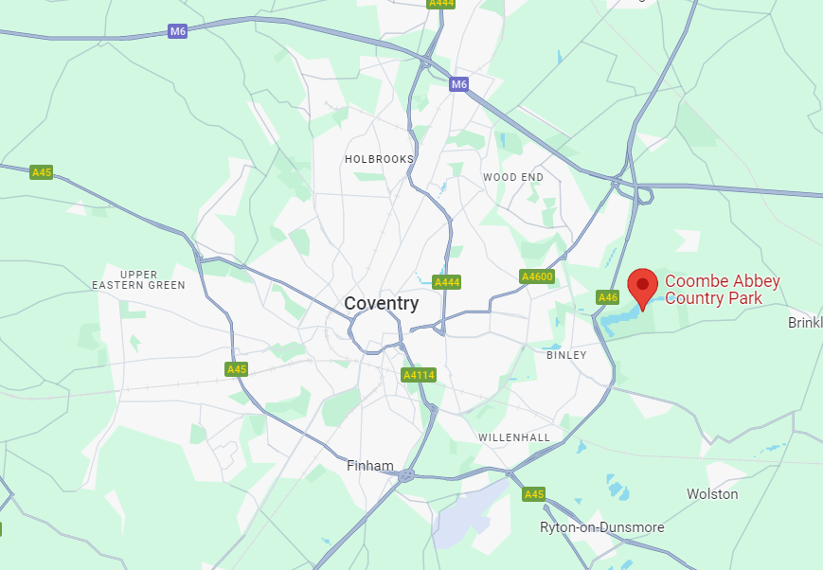
Throughout the park we had 7 sites that were located every 200m away from the visitor centre. Our study sites were chosen using systematic sampling. We walked along a transect in equal distances away form the visitor centre, this allowed us to see if there was a clear change with distance from the visitor centre.
Hypothesis
Our hypothesis is that with distance from the visitor centre, the environmental quality of the area will improve.
Risk Assessment
Hazard | Likelihood (1-5) | Severity (1-5) | Overall Risk (1-25) | Mitigation
Slips, trips and falls | 3 | 3 | 9 | Wear sensible shoes (trainers). Look where you are walking. Stay in groups.
Extreme weather | 3 | 2 | 6 | Suncream, appropriate clothing (hat, raincoat, waterproof trousers). Check forecast to be best prepared.
Traffic related incident | 2 | 5 | 10 | Only one main road in the site. Students to stay on the footpaths throughout the day and use the crossing to return to the coach.
Becoming lost/disorientated | 2 | 2 | 4 | Have a mobile phone with emergency contact or GPS. Stay as a group.
Interactions with the public | 4 | 2 | 8 | Be friendly when approaching people. Stay in public spaces. Stay as a group.

Methodologies:
Method | What we did? | How it answers title. | Limitations
Pedestrian Count | At each site, we tallied the number of people walking past in one direction. This was conducted for 5 minutes using a stop watch. | This helped to see if the number of visitors/people decreased with distance from the visitor centre, and therefore if there were less people with distance from economic activity. We hypothesised that with a lower pedestrian count there would be a high level of environmental quality. | Some people walked past the group several times and people took different routes around the park leading to them walking in different directions. Therefore, this may have not given a full overview of how busy the park was.  Park was quiet in the afternoon of a working day so some areas had no people pass by.
Environmental Quality Index / Surveys | EQS are used to measure the environmental quality of each location.  We measured the environmental quality of six descriptors within three locations at each study site – ranking them from 1-5.  A total score can be calculated to identify how sustainable the area is. | Environmental Quality Surveys (EQS) can be used to compare different sites within the Coombe Abbey, to see if it improves with distance from economic activity.  Looks at a range of aspects within sustainability – i.e: waste, infrastructure, green spaces, footpath erosion. | They are subjective to the person conducting the survey and so the same individual should record this each time to reduce disparities. The bounds of the area being measured for environmental quality could be limited or hard to define.
Noise pollution – sound mapping and decibel reading | - Measuring noise using a decibel reader  - Record value in decibels  - Sound mapping  - Draw an icon or list words linking to noises you can hear around your location. They must represent which locations the noise comes from and how far it is (roughly) from you. | This allowed us to identify the types of noise pollution to categorise them into those related to visitors i.e. talking, music, bikes, playground, vehicles and those natural sounds.  Decibel readers allowed us to have a quantitative data recording to see how noisy each site was. | - Decibel readers did not always work and therefore some students used apps making it less reliable.  - Sound mapping is more subjective.  - Some noise came from the groups taking data collection which could skew results.
Litter Count - Quadrat | - At your location, gently throw your quadrat North, East, South and West.  - Be wary of the people and wildlife around you.  - In your quadrat record any litter, and if possible the size of the litter visible at the surface, using a ruler.  - Total a % of quadrat that is filled with litter. | Would expect to see less litter with distance from the visitor centre/café.  The less litter the better the environmental quality. | - Some areas, i.e kiosk in the park and Go Ape saw higher amounts of litter even though they were further from the visitor centre. This was an anomaly.

Method | What we did? | How it answers title | Limitations
Questionnaire/ Interviews | Asked visitors in the park their opinions on the environmental quality of the park as well as questions about how they got to the park and how regularly they went.  Also asked about the impacts of the visitor centre on the park. | Helps to understand what people think about the park, the reason for their visit as well as their perception of environmental quality. | Subjective opinions from the public.  Some people had not been into the visitor centre and just used walking trails.  Not many people around in the park so number of responses per site was very limited and convenience sampling was used instead of random/systematic.

Sampling Strategies
As mentioned previously, we used stratified sampling to locate our two study sites: Eastside and Digbeth. Then random locator cards were used within each site to choose locations (at random) to collect the data from. 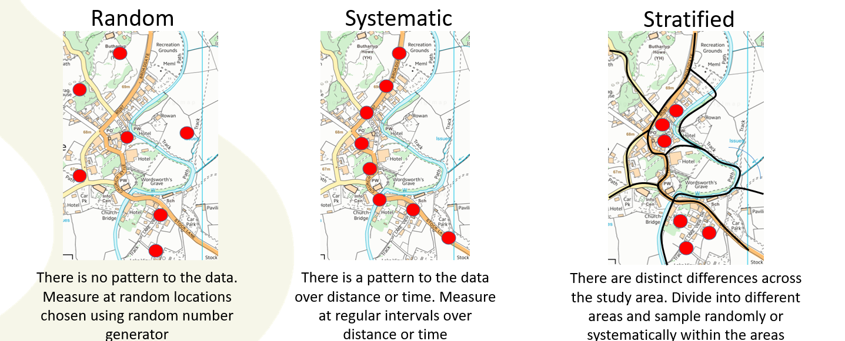
Sampling Strategy | Image | Description | Advantages | Disadvantages
Random | 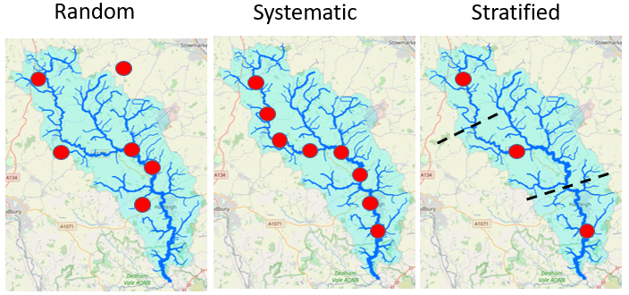 | Selecting a person to interview or site to measure, at random. | Can be used with large sample populations.  Avoids bias | Can be time consuming.  Clustering leading to areas unsampled.
Stratified |  | Dividing sampling into groups, i.e.: three sites from each section of coastline, or five people from each age range. | Avoids bias that can arise from random and systematic sampling as ensures that each group is fairly represented.  Ensures all areas are covered | Difficult to know exactly which subsets of data you want to include.  Access may be a problem.  Requires good prior knowledge of an area
Systematic |  | collecting data in an ordered or regular way, e.g. every 5 metres or every fifth person. | Quick and easy to carry out.  Shows changes over distance/time easily.  Ensures good coverage of an area.  Accurately reflects continuous changes in variables. | Can inadvertently pick up bias, i.e.: sampling every 25 meters along a transect could lead to the middle of the road.

Data Presentation
Data Used | Data Presentation | Advantages | Disadvantages
Questionnaires/litter count | Compound/Divided Bar Charts  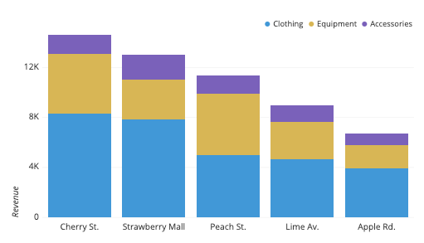  Pie Charts (when converted to percentage)  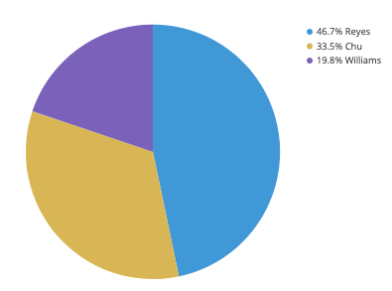 | - Easy comparison for different categories – i.e: Independent vs Chain  - Allows for estimation at a glance.  - It also allows for multiple data sets to be shown – could show data on one chart for easy comparison between sites.  - Shows proportional representation of the data as a percentage – could show different uses of building or chain vs. independent.  - Easy to show comparison between categories and two pie charts can be easily compared. | - Easily manipulated by anomalous results.  - Clustered if there are too many categories.  - Can be difficult to easily extract data when stacked.  - Difficult to read precisely as it is converted to a percentage of the total.  - Difficult to see trends across different sites when there are lots of sites.
Environmental Quality Survey  Pedestrian counts | Radar Graphs  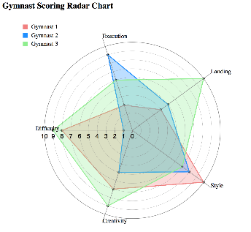  Bar Charts  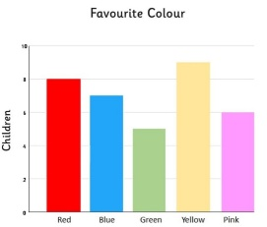  Proportional Circle Map  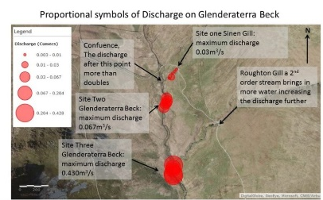 | - Can be used for multivariate observations.  - Can easily visualise the results.  - Allows for comparison across sites as multiple can be stacked in different colours.  - Easy comparison for different locations.  - Allows for estimation at a glance.  - Matches up to a location – can see how data varies spatially and therefore if some areas are more sustainable than others.  - Size of circle increases with the total EQS score.  - Easy to visualise. | - Too many variables can distort data.  - Can be difficult to spot anomalies.  - Too many data series can make it difficult to read.  - They are easily manipulated by anomalous data results.  - Difficult to present multiple data sets.  - Simplistic  - Can be difficult to read individual data values.  - Can cover up other parts of the data making it more difficult to read.  - Need to have taken the coordinates at each site where data was collected.
Questionnaires (closed) | Pie Charts  Bar Charts | - Shows proportional representation of the data as a percentage – could show different uses of building or chain vs. independent.  - Easy to show comparison between categories and two pie charts can be easily compared.  - Easy comparison for different locations.  - Allows for estimation at a glance. | - Difficult to read precisely as it is converted to a percentage of the total.  - Difficult to see trends across different sites when there are lots of sites.  - They are easily manipulated by anomalous data results.  - Difficult to present multiple data sets.  - Simplistic
Questionnaires/ Interviews (open) | Word Clouds | - Easy to create.  - Easy to visualise and understand common trends in peoples responses.  - Good for short answer responses. | - Non-specific terminology can get included making anomalies.  - Some people may not understand key geographic terms.  - Too many responses can complicate the word cloud and too few doesn’t outline key trends.
Sound Mapping | 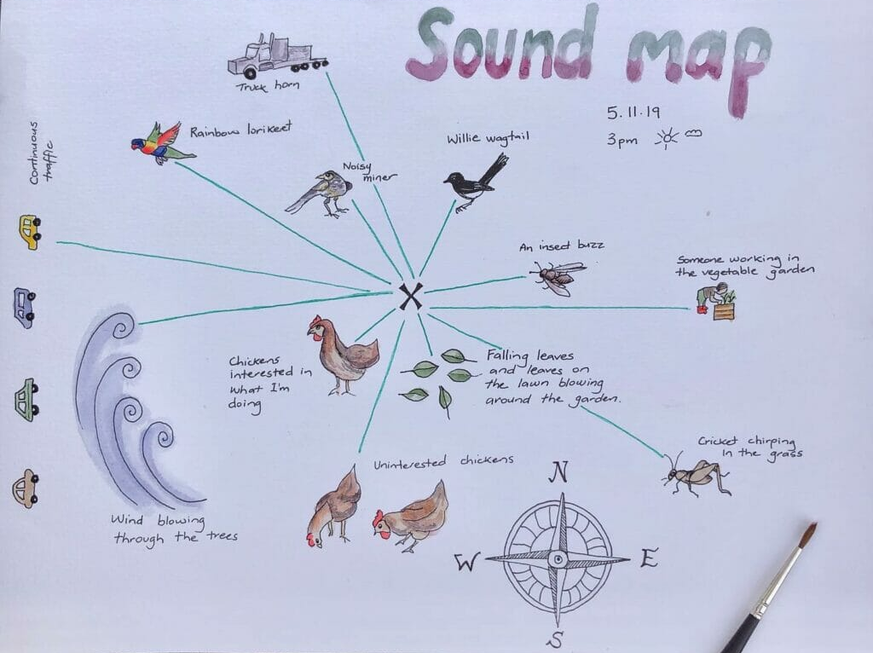 | - Visual representation of sounds  - Allowed to spot anomalies  - Could work out distances of noises and link to decibel reading | - Might not have accurate distances and locations and therefore may not truly represent the data collected.  - May not match decibel reading.

Conclusions:
Overall the data showed that environmental quality did improve marginally with distance from the visitor centre. There were some anomalies in two locations: Kiosk in the Park and Go Ape – this was likely due to there being more people located in these areas due to the economic activity.
Areas with a higher pedestrian count had the highest amount of noise and litter and therefore met our hypothesis that environmental quality would be worse around the economic activities.
Taking photos helped to analyse our data by reminding us of how busy the areas were as well as being able to look back at litter counts to check for errors.
There was evidence of litter being tidies in these areas and on the whole the whole area was rather clean suggesting that economic activity meant that is could be kept tidy.
Questionnaires were very limited but people did think that the cleanliness of the park was one reason that made the park appealing, although most people travelled to the park by car and therefore the environmental impact would be impacted.
Due to the time of day and it being a work day, the park being very quiet was a large limitation to the study and using a weekend or evening may have changed the results. In the future it may be worth comparing it to another large park that does not have economic activity.

