FIELDWORK BOOKLET

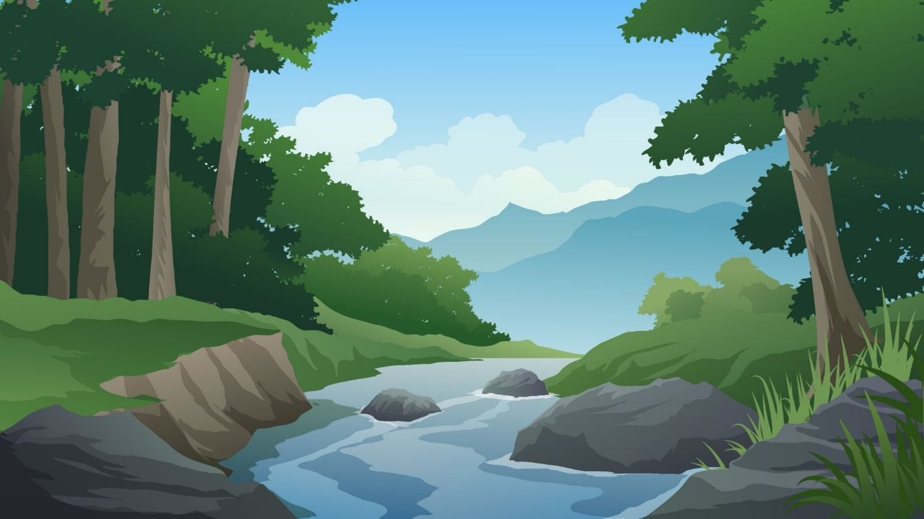

Physical Geography: Rivers

Investigation Title:
To what extent do the characteristics and processes of the Smite Brook change with distance from the source?

Specification

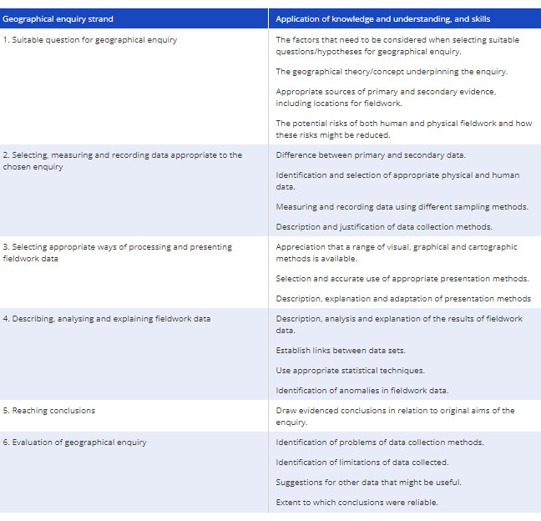

Study Site: Smite Brook, Coombe Abbey Park
Location of Smite Brook
Smite Brook is a tributary of the River Sowe which runs from Bedworth to Coventry. Smite Brook is located within Coombe Abbey Park, which is where it was accessed for the field work.The River Sowe then feeds into the river Avon as it continues through Warwickshire and the West Midlands.

Why was the location suitable?
The location was suitable as it was a local river that is accessible across two distinct courses. It also includes some small-scale management which can show the human impact on the processes and characteristics of the river. It was possible to conduct several different primary data collection methods to see changes in the upper and middle courses.

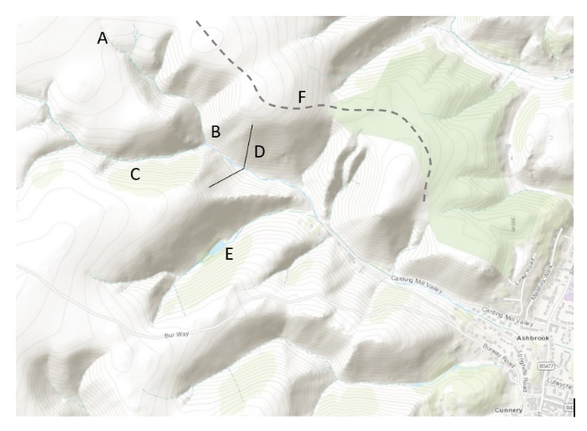
Features of a River: A drainage basin is made up of many components. The figure shows some of the components of a drainage basin
A = Source
B = Confluence
C = Tributary
D = V shaped valley
E = Lake/Store
F = Watershed

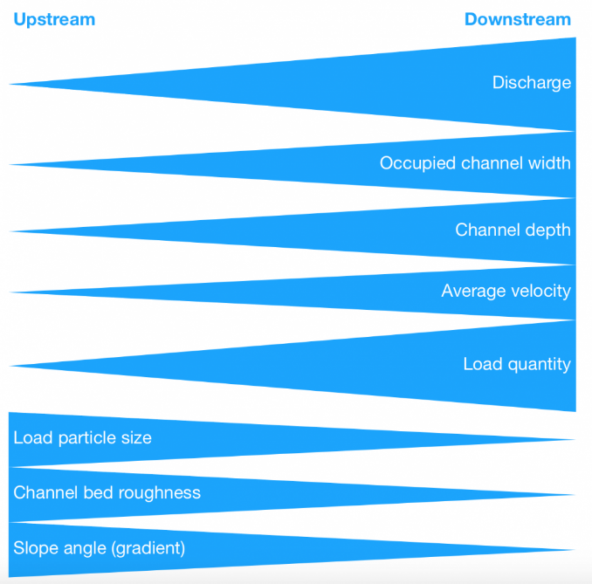
Hypothesis
A hypothesis is an educated guess/estimate of what the outcome of our fieldwork will be.
Our investigation of how channel characteristics change downstream relate to the Bradshaw Model.
This suggests that downstream discharge, channel width, channel depth, the cross-sectional area, velocity, and particle roundness will increase.
Whereas, particle size, and slope gradient will decrease.
Our hypothesis matches that of the Bradshaw model.

Risk Assessment
Hazard | Likelihood (1-5) | Severity (1-5) | Overall Risk (1-25) | Mitigation
Slips, trips and falls | 4 | 3 | 12 | Sturdy footwear (walking boots or wellies). Look where you are walking. Stay in groups.
Extreme weather | 3 | 2 | 6 | Suncream, appropriate clothing (hat, raincoat, waterproof trousers). Do not enter river after heavy rainfall. Check forecast.
Consume contaminated water | 1 | 4 | 4 | Use anti-bacterial hand gel and wash hands before eating. Do not drink water.
Becoming lost/disorientated | 2 | 2 | 4 | Have a mobile phone with emergency contact. Stay as a group. Emergency whistle.
Strong currents/ deep water may cause loss of footing and result in drowning | 2 | 4 | 8 | Wear sensible footwear. Areas with particularly strong current or deep water should be avoided. Avoid steep areas and waterfalls.

Primary Quantitative Data Methodologies
Method to Measure | Image | Equipment | Description | Potential Limitations
Width | 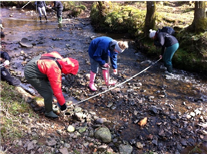 | - Tape Measure | Pull the tape measure bank to bank, perpendicular to the river channel.  Pull tape measure taught and take one reading of width. | If not pulled taught, the measurement could be overestimated.
Depth | 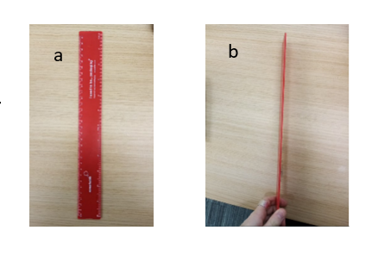 | - Tape Measure  - Ruler | Divide the width by 10 – creating 11 points (including banks)  Place ruler in streamline. Put ruler on the river bed.  Take a reading using thumb and finger at point where rivers level is.  Read and record depth from ruler. | If not streamline, it may push water further up ruler, over estimating depth.  Use thumb and finger to prevent any human error if not at eye level.
Cross Sctional Area | 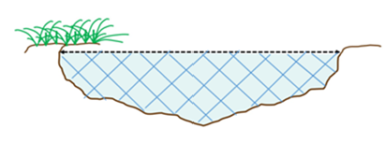 | - Width data  - Depth data | Cross sectional area (m2) = width (m) x mean depth (m) | Miscalculation  Previous limitations of depth or width measurements.
Velocity Method 1 | 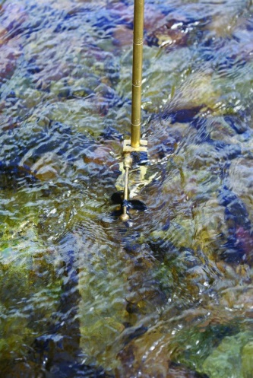 | - Hydro-prop (and impeller)  - Stopwatch | Hold the hydro-prop with the impeller facing upstream.  Place it level with the surface of the rivers flow.  Use a stopwatch (or timer on a phone) to measure how long it takes for the impeller to travel the distance of the rod.  Calculate the velocity (m/s) = 0.0277 + (3.281 (m) ÷ time (s)). 0.0277 is the manufacturers added potential error. 3.281 is the distance of the coil on the impeller.  Take repeat velocity readings at each site, such as left-hand side, centre and right-hand side of the channel. Calculate the mean velocity. | Manufacturers have acknowledged some equipment error.  Human error – reaction time to stop the stopwatch.  Holding the hydro-prop in at different depths can skew data.
Velocity Method 2 | 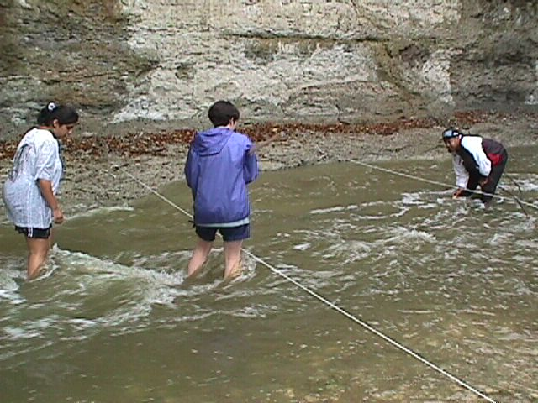 | - Float (dog biscuit/ cork)  - Stopwatch  - Tape measure | Measure 10 metres along the river. Make sure that you put markers at the start and finish.  Place float at the start of measure section and time using the stopwatch how long it takes to reach the end marker.  Calculate the velocity using speed (m/s) = distance (10m) / time (s).  Take repeat velocity readings at each site, such as left-hand side, centre and right-hand side of the channel. Calculate the mean velocity. | Float can get stuck behind obstacles or in pools and therefore creates an error.  Velocity may vary along the 10 meters so will not reflect cross section perfectly.  Human error – reaction time to stop the stopwatch.
Discharge |  | - Velocity data  - Cross sectional area data | Discharge (cumecs) (m³/s) = cross sectional area (m²) x velocity (m/s)
Gradient | 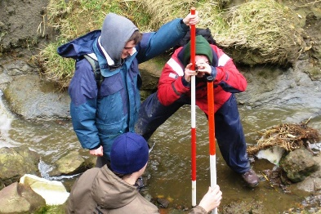 | - Ranging Poles/ two people  - Clinometer  - Tape measure | Stand in the middle of the channel with a ranging pole.  A second person should stand 10 m downstream.  Put the clinometer at set height on the ranging pole and align with the same mark on the second ranging pole.  Using the clinometer take the angle showing the gradient difference. | Clinometer moves easily so reading may be off slightly.  Students may not be same height or have not aligned poles well.  Gradient within the 10m may vary, particularly if there is a waterfall.
Sediment Size | 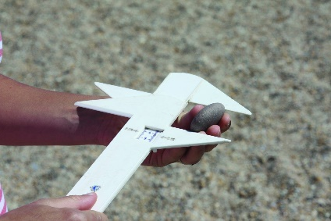 | - Calliper | At each site, randomly select sediment across the channel.  For each rock, find the long axis (the longest part).  Using the calliper, measure the long axis (mm). | Some rocks could have a large, short axis, may not represent size well.  Very angular rocks may be difficult to measure.
Sediment Roundness | 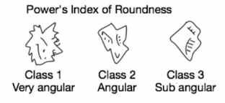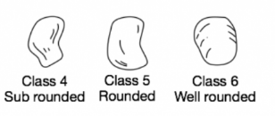 | - Power’s Roundness Index Identification Card | For each sediment collected for sediment size, take a roundness measurement.  Use Power’s index of Roundness descriptions and images to identify which value the sediment is. | Perception based – different people may have different opinions, so if different people recorded this each time, it would be less reliable.

Primary Qualitative Data: Field Sketch
A field sketch can be used to identify the different features at each course of the river.
Whilst in each stage of the river course, a field sketch looking down stream should be drawn with annotations of the different features visible. Date, time and weather conditions should be mentioned as well.
May be challenging if there is poor weather (heavy rainfall/fog) that may make elements not visible.
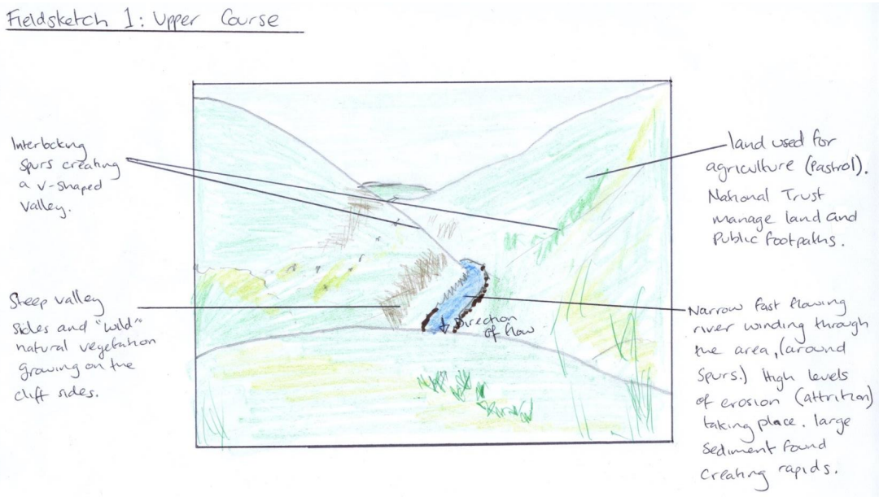Sampling Strategies:
Sampling is a... shortcut method for investigating a whole population. Data is gathered on a small part of the whole parent population or sampling frame and used to inform what the whole picture is like.
Why Sample?
In reality there is simply not enough; time, energy, money, labour/man power, equipment, access to suitable sites to measure every single item or site within the parent population or whole sampling frame.
Sampling Strategy | Image | Description | Advantages | Disadvantages
Random | 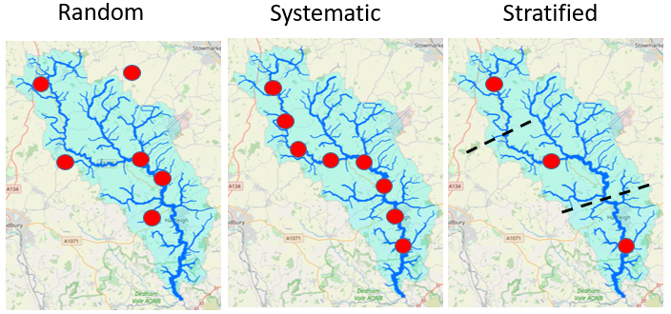 | Selecting a person to interview or site to measure, at random. | Can be used with large sample populations.  Avoids bias | Can be time consuming.  Clustering leading to areas unsampled.
Stratified |  | Dividing sampling into groups, i.e.: three sites from each section of coastline, or five people from each age range. | Avoids bias that can arise from random and systematic sampling as ensures that each group is fairly represented.  Ensures all areas are covered | Difficult to know exactly which subsets of data you want to include.  Access may be a problem.  Requires good prior knowledge of an area
Systematic |  | collecting data in an ordered or regular way, e.g. every 5 metres or every fifth person. | Quick and easy to carry out.  Shows changes over distance/time easily.  Ensures good coverage of an area.  Accurately reflects continuous changes in variables. | Can inadvertently pick up bias, i.e.: sampling every 25 meters along a river could be at a waterfall – inaccessible.  May exclude key sites

Secondary Data
Your primary data will focus on spatial changes in a river channel. Secondary data is invaluable for considering the potential for temporal changes and their impacts (changes over time).
In a river enquiry suitable secondary data may include:
- River discharge data from the Environment Agency – to compare the discharge to an average or different times of the year.
- Weather data from the Meteorological Office (Met Office) – to help understand reasons as to why the discharge may be higher/lower than expected. Also to prepare for risk assessment.
- Old photographs of the river sample site – to compare temporal changes of the site. Understand why and how some characteristics have changed over time.
- Newspaper articles/websites about the river - gives reasons for any changes that may have occurred prior to fieldtrip.
- Ordnance Survey maps to identify the sample sites and map each site location or randomly select sites using GIS.
- Geology maps – Understanding the relief and topography of the land – may explain velocity/discharge levels.
- Aerial photographs – understand the characteristics of the area ie: dense vegetation / steep terrain / nearby urbanisation and how that could alter the results found in the investigation.

Data Presentation
Types of data:
- Quantitative data records quantities (e.g. numbers, sizes, frequencies).
- Qualitative data records subjective qualities (e.g. opinions and attitudes).
- Discrete data can only take certain values (e.g. whole numbers)
- Continuous data can take any value (e.g. length, width, time)
Guide on how to display data: Rivers Fieldwork: Displaying results with simple Excel graph (geography.org.uk)
Presentation type | Data Used | Image | Justification
Line graph to show cross sectional area | Width  Depth | 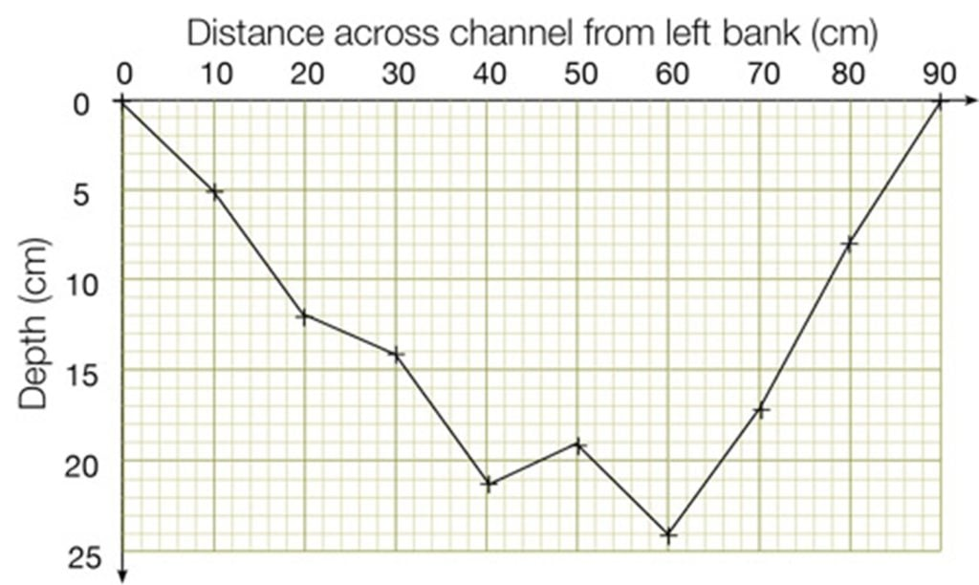 | Both axis have continuous data.  Multiple cross sections will show the changes in width and depth as you go downstream.
Bar chart to show cross sectional area across sites | Cross sectional area  Sites | 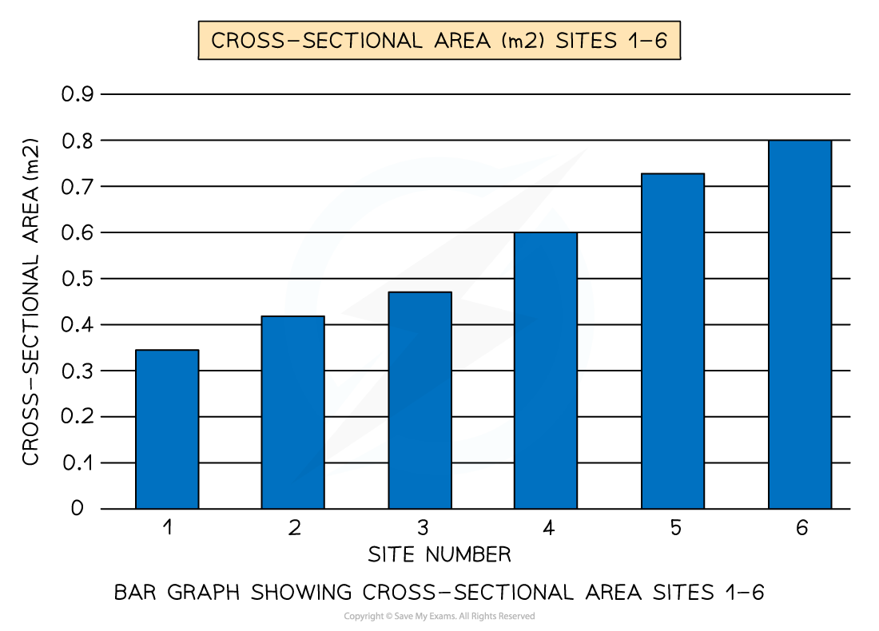 | Shows trends and differences well between sites.  Can see the changes downstream and weather it fits hypothesis.
Scatter graph to show relationship between width and depth | Width  Depth | 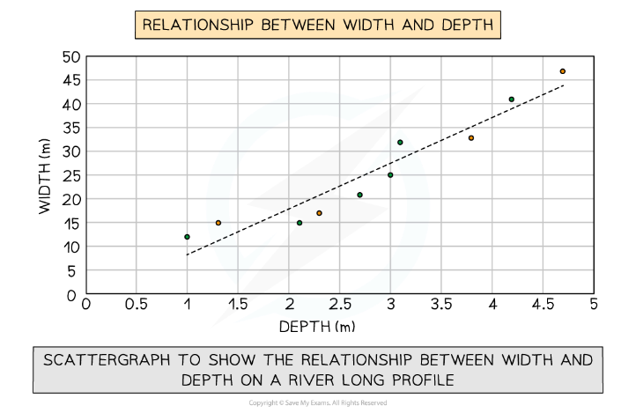 | Shows if there is a relationship between two data sets.  Width and depth should both increase as you go downstream and therefore, they could be related.  Shows a positive correlation.
Pie chart to show the Power’s Index of Roundness of Sediment | Sediment roundness | 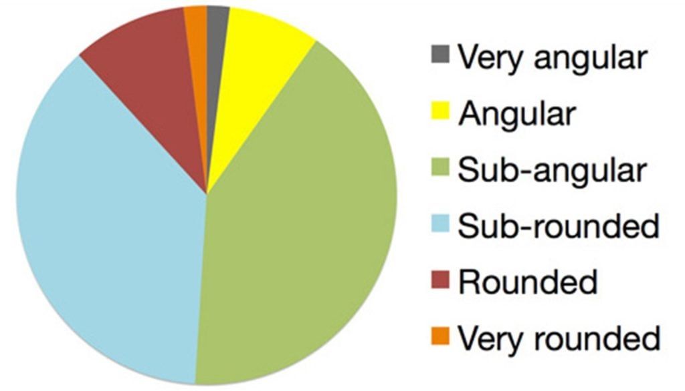 | Shows up population of each roundness at each site.  Can be compared and percentages can be added to show the most common roundness at each site.
Scatter graph showing relationship between sediment shape and sediment roundness | Bedload size  Bedload shape | 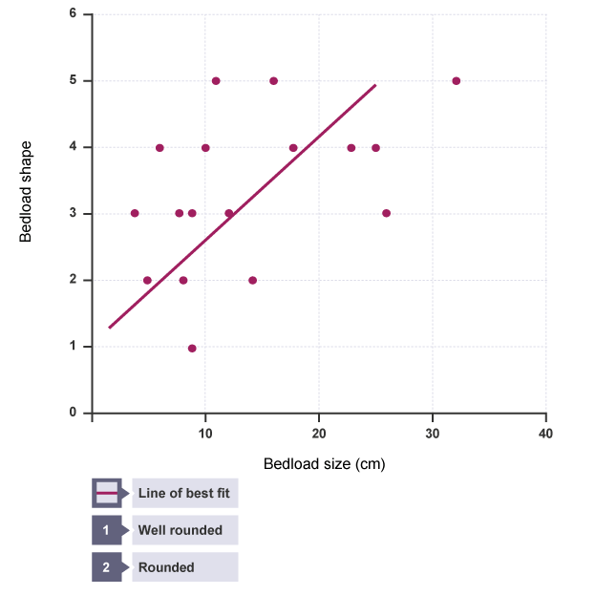 | Used to show a relationship between two data sites.  Correlation tests.  Line of best fit shows if there is a correlation: positive/negative/no correlation.  Line of best fit is a form of analysis.
Proportional symbols map to show discharge across sites | Site locations  Discharge data | 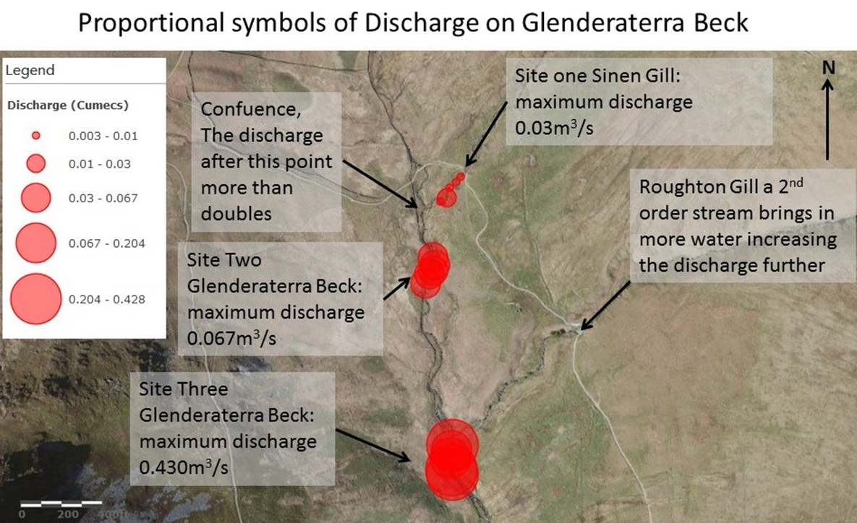 | Symbols get bigger with bigger values.  Plots onto site locations so changes in discharge can be seen downstream.  Annotations show analysis of results and linking to the hypothesis and investigation aims.
Line graph to show long profile of Ashbrook River | Gradient  Distances between sites | 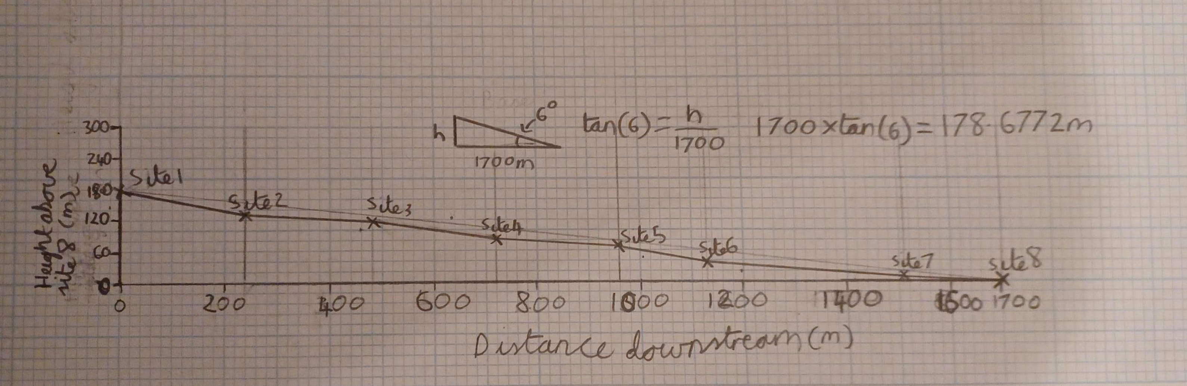 | Shows how the steepness will change along the profile of the river. Should expect to see steeper at the upper course compared to a flatter lower course.

Analysis
- Once data has been collected and presented it needs to be analysed.
- The data, which is collected from the river such as width, depth, velocity is quantitative data and will need to be analysed using statistical methods.
- One of the main statistical methods used in a river enquiry will be the mean where mean depth or velocity needs to be calculated.
- Comparisons can be drawn to Bradshaw model.
- Identification of anomalies.
Example question and answer:
Explain the methods used to analyse your data.
We entered our data on the data sheets provided by our teachers to show width, depth and velocity measurements at the three sites that we had been allocated. We also visited the other three sites and made field sketches of these locations. We recorded any issues with the data collection on those sheets. Once we returned to school, we calculated the discharge (Q = w.d.v) for each site: Q = discharge w = width d = depth v = velocity. We then compared them with the results from the other group who visited in the afternoon and discussed possible reasons for differences; these would have to be something to do with the precise places chosen to take the measurements or the accuracy of those measurements because nothing changed in the few hours between the measurements being made. We also had access to data collected by the previous year’s students so that we could look at differences which may affect the reliability of our results. Having drawn up tables of data we then put them on a line graph which clearly showed the downstream changes; we annotated that graph to explain any variations from the Bradshaw model predictions.
Limitations
Limitation | Explanation | Improvements for next time
Sampling strategies | Systematic sampling for sample sites – worked well for the upper and middle course, however lower course river did not meet this and was significantly further downstream. This would mean that velocity, width and depth had a larger difference compared to other sites as it was less gradual. | Ensure that all sites are 100m apart from each other downstream.  Will better show changes with distance from the source and more likely to fit the hypothesis and inquiry.
Sampling size | For sediment samples the amount taken per site varied and therefore the results cannot be as reliable to show results. Small data set of 9-11 samples per site which may not represent the large amount of sediment load carried in the river. | Having a higher number of sediment samples at each site (50 per site).  Consistent across sites improves comparison.  Statistical tests may better show a correlation between shape and size as there is a larger data set.
Time of day/Time of year | Fieldwork carried out in winter months, with higher expected rainfall than other seasons in the year. May be seasonal variation.  Not all data was collected at the same time, therefore there may have been changes in discharge due to throughflow reaching the channel or changes in precipitation. | Little changes could be made, however completing each site as close to each other time wise as possible. Could take and check precipitation amounts in the future.  Return at different points in the year or compare the data to secondary data from other seasons or time of day to see what the variation could be.
Weather conditions | Heavy rainfall in the afternoon of the fieldtrip meant that discharge increased due to higher precipitation. Therefore, there were bigger contrasts between the data collection in the morning, pre-rainfall, compared to that collected during and after the heavy rainfall which increased discharge massively. | Similar to above. Little control.  Check weather forecasts and pick a fieldwork day in which weather is more consistent for the amount of time fieldwork is being collected.  Repeat the collection and draw comparisons to different weather conditions. Record weather conditions so analysis of data could be improved.
Equipment errors | Hydro-prop and impellor – got stuck and would not spin easily. This added time onto the speed and therefore would have altered the velocity and discharge values. | Checked equipment before use.  Hold the hydro-prop and impellor at same level to reduce problems where possible.
Equipment errors | Clinometer – moves easily and slight movement meant that readings of angle could have been slightly wrong. | When using ranging poles, hold still against pole to reduce movement.
Equipment errors | Calliper – one groups broke, therefore they had to use a ruler and the mm reading is less accurate compared to other data sets. | Have back up equipment to reduce this error in the future or borrow from another group.
Equipment errors | Stopwatch – buttons get stuck and therefore slower to stop the time readings which could have altered the speed/velocity/discharge data. | Check equipment before use. Have spares.
Human error | Reaction time – different people taking timings may lead to different reaction times.  Individuals’ reaction time could be slow making whole data set having a lower discharge. | Have the same person consistently take the speed times at each site rather than having different groups at different sites.
Human error | Not pulling tape measure taught – leads to over estimation of width and therefore increasing the number of anomalies. | Check each time that it is pulled taught. Have the same two people doing this each time to be consistent.
Human error | Inputting data – some groups entered their widths in cm rather than m which led to a large anomaly in site 2. Other data set of sediment size was wrong as over 100 were inputted in a site when only 9-11 were collected at each site. This meant that much of the data did therefore not meet what was expected from the Bradshaw Model. | Check data measurements when inputting into the spreadsheet. Altering or amending any clear mathematical mistakes in excel.  Take any clear anomalies out to review what the data could potentially look like in a different scenario.
Human error | People of different heights when taking gradient/not measuring height of people. Meant that gradients could be over/under-estimated depending on differences in height and therefore might not be well reflected in the long profile. | Use ranging poles as these will be more consistent between sites.  Or, measure the heights of people so that calculations when working out the long profile will be more accurate.
Human error | Using different equipment – some groups used hydro-prop, whereas others used a float which each have different limitations. Therefore, less reliable as not consistent. | Ensure there is enough equipment for everyone to use the same.  Or, to have each group take a full set of readings at each site so that they do not use any data where different equipment was used.

Conclusions
Overall, much of the data matched that of the Bradshaw model.
- Most of velocity increased downstream – anomaly from data inputting.
- Discharge data increased downstream.
- Width increased downstream – anomalies on site 4 and 5.
- The % of angular rocks reduced downstream.
However, some of the data did not fit the Bradshaw model.
- Bedload size varied across sites fluctuation – likely due to a small sample size.
- Depth also varied with particularly higher lower course than expected – could be due to heavy rainfall.
Following the improvements in the limitations table, it would be expected that our results should better fit the Bradshaw model if repeated.
Next time, all groups should check their data inputted, and use their own data collected to have the most accurate and reliable data set possible as this would prevent gaps in the data or excessive anomalies.

