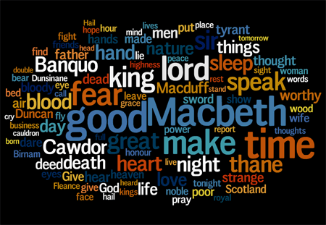
Macbeth
Student Name:____________________
Teacher:___________________

Learning Question: What is Power?
What is the definition of power?

A reminder of the
Literature Assessment Objectives...

Lit AO1: Use textual references, including quotations, to support and illustrate interpretations.

Lit AO2: Analyse the language, form and structure used to create meanings and effects, using relevant subject terminology where appropriate.

Lit AO3: Show understanding of the relationships between texts and the contexts in which they were written.
Macbeth: The Simplified Story
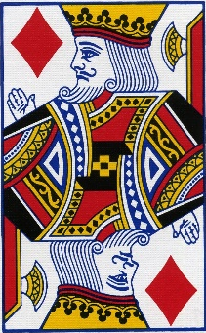
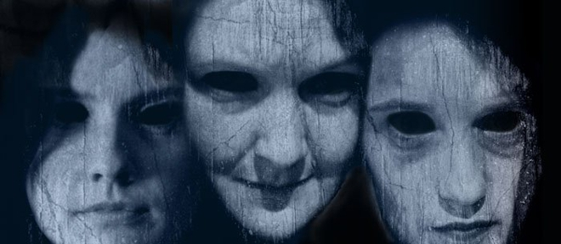
The play begins with the brief appearance of a trio of witches and then moves to a military camp, where the Scottish King Duncan hears the news that his generals, Macbeth and Banquo, have defeated two separate invading armies—one from Ireland and one from Norway.
Following their battle with these enemy forces, Macbeth and Banquo encounter the witches as they cross a moor. The witches prophesy that Macbeth will be made thane (a rank of Scottish nobility) of Cawdor and eventually King of Scotland. They also prophesy that Macbeth’s companion, Banquo, will start a line of Scottish kings, although Banquo will never be king himself.
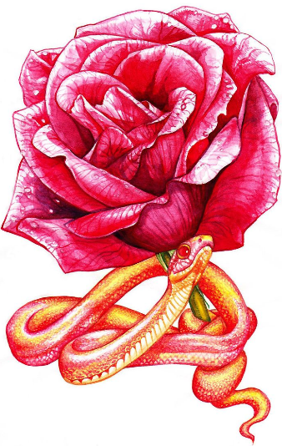
The witches vanish, and Macbeth and Banquo treat their prophecies sceptically until some of King Duncan’s men come to thank the two generals for their victories in battle and to tell Macbeth that he has indeed been named thane of Cawdor. The previous thane betrayed Scotland by fighting for the Norwegians and Duncan has condemned him to death. Macbeth is intrigued by the possibility that the remainder of the witches’ prophecy—that he will be crowned king—might be true, but he is uncertain what to expect. He visits King Duncan, and they plan to dine together at Inverness, Macbeth’s castle, that night. Macbeth writes ahead to his wife, Lady Macbeth, telling her all that has happened.
Lady Macbeth suffers none of her husband’s uncertainty. She desires the kingship for him and wants him to murder Duncan in order to obtain it. When Macbeth arrives at Inverness, she overrides all of her husband’s objections and persuades him to kill the king that very night.
He and Lady Macbeth plan to get Duncan’s two chamberlains drunk so they will black out; the next morning they will blame the murder on the chamberlains, who will be defenceless, as they will remember nothing.
While Duncan is asleep, Macbeth stabs him, despite his doubts and a number of supernatural portents, including a vision of a bloody dagger. When Duncan’s death is discovered the next morning, Macbeth kills the chamberlains—pretending to be outraged at their crime—and soon becomes king. Duncan’s sons Malcolm and Donalbain flee to England and Ireland, respectively, fearing that whoever killed Duncan desires their deaths as well.
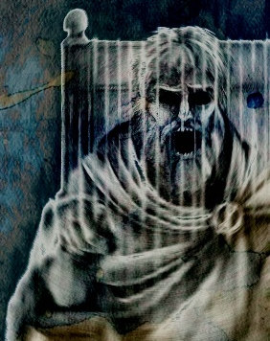
Fearful of the witches’ prophecy that Banquo’s heirs will seize the throne, Macbeth hires a group of murderers to kill Banquo and his son Fleance. They ambush Banquo on his way to a royal feast, but they fail to kill Fleance, who escapes into the night. Macbeth becomes furious: as long as Fleance is alive, he fears that his power remains insecure.
At the feast that night, Banquo’s ghost visits Macbeth. When he sees the ghost, Macbeth raves fearfully, startling his guests, who include most of the great Scottish nobility. Lady Macbeth tries to neutralize the damage, but Macbeth’s kingship now falls under suspicion from his nobles and subjects.
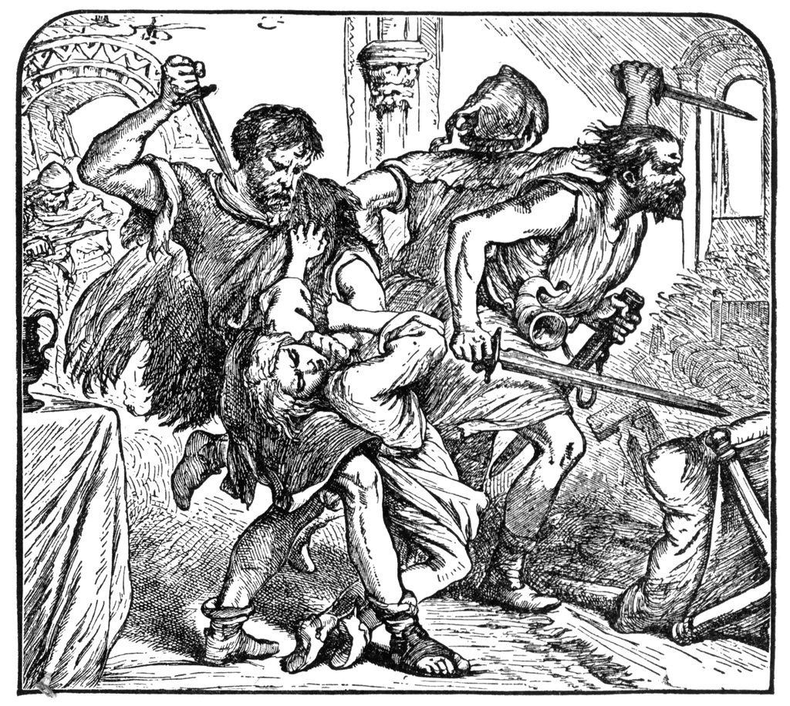
Frightened, Macbeth goes to visit the witches in their cavern. There, they show him a sequence of demons and spirits who present him with further prophecies: he must beware of Macduff, a Scottish nobleman who opposed Macbeth’s accession to the throne; he is incapable of being harmed by any man born of woman; and he will be safe until Birnam Wood comes to Dunsinane Castle. Macbeth is relieved and feels secure, because he knows that all men are born of women and that forests cannot move. When he learns that Macduff has fled to England to join Malcolm, Macbeth orders that Macduff’s castle be seized and, most cruelly, that Lady Macduff and her children be murdered. When news of his family’s execution reaches Macduff in England, he is stricken with grief and vows revenge.
Prince Malcolm, Duncan’s son, has succeeded in raising an army in England, and Macduff joins him as he rides to Scotland to challenge Macbeth’s forces. The invasion has the support of the Scottish nobles, who are appalled and frightened by Macbeth’s tyrannical and murderous behaviour.
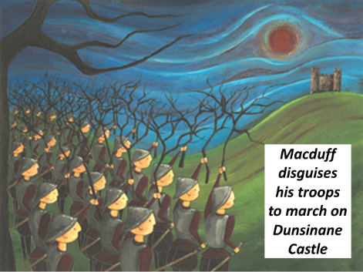
Lady Macbeth, meanwhile, becomes plagued with fits of sleepwalking in which she bemoans what she believes to be bloodstains on her hands. Before Macbeth’s opponents arrive, Macbeth receives news that she has killed herself, causing him to sink into a deep and pessimistic despair.
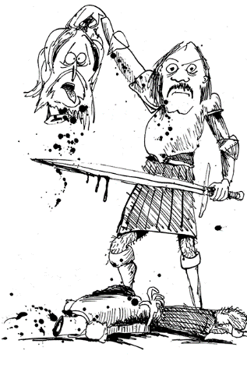
Nevertheless, he awaits the English and fortifies Dunsinane, to which he seems to have withdrawn in order to defend himself, certain that the witches’ prophecies guarantee his invincibility. He is struck numb with fear, however, when he learns that the English army is advancing on Dunsinane shielded with boughs cut from Birnam Wood. Birnam Wood is indeed coming to Dunsinane, fulfilling half of the witches’ prophecy.
In the battle, Macbeth fights violently, but the English forces gradually overwhelm his army and castle. On the battlefield, Macbeth encounters the vengeful Macduff, who declares that he was not “of woman born” but was instead “untimely ripped” from his mother’s womb (what we now call birth by caesarean section). Though he realizes that he is doomed, Macbeth continues to fight until Macduff kills and beheads him. Malcolm, now the King of Scotland, declares his benevolent intentions for the country and invites all to see him crowned at Scone.

12-Step Macbeth: Call & Response
1. On a dark, stormy Scottish night, three witches plot to meet Macbeth on his way home from battle.
When shall we three meet again? In thunder, lightning or in rain?
2. Macbeth fought bravely, decapitating his opponent and gaining victory for King Duncan. Exhausted from battle, Macbeth and his friend Banquo meet the witches, who make a prophecy…
All hail Macbeth, that shalt be king hereafter.
3. Lady Macbeth is afraid her husband is too weak-willed to fulfil his destiny. When she hears that King Duncan is coming to their castle, she decides they must kill him and persuades Macbeth to do it…
Look like th’innocent flower, but be the serpent under’t.
4. Lady Macbeth gets the king’s bodyguards drunk, and as they sleep Macbeth murders the king and smears the drunken bodyguards with blood to frame them. He is tortured by what he has done and hears voices in his head.
O, full of scorpions is my mind, dear wife.
5. Macbeth is crowned King of Scotland – and has his friend Banquo killed to keep him quiet about the witches’ prophecy. At his coronation feast Macbeth sees Banquo’s ghost and is terrified.
Quit my sight! Let the earth hide thee!
6. Macbeth meets the witches again, and they give him three messages…
Beware Macduff!
None of woman born shall harm Macbeth.
Macbeth shall never vanquished be until Great Birnam Wood to high Dunsinane Hill shall come against him.
7. Macduff is King Duncan’s loyal servant, so Macbeth attacks his castle and has his family killed.
Give to th’edge o’th’sword his wife, babes, and all…
8. Lady Macbeth feels so guilty that she begins to walk and talk in her sleep – and constantly washes her hands to clean off the blood of those Macbeth has murdered.
Out damned spot! Out I say! Here’s the smell of blood still.
9. Macduff gathers his army near Birnam Wood, close to Dunsinane Castle – but because of the witches prophecies, Macbeth is not worried.
I will not be afraid of death and bane till Birnam Forest come to Dunsinane.
10. Macduff orders his men to chop down branches from the trees and disguise themselves as they march on the castle. Macbeth realises that the second prediction has come true.
And now a wood comes towards Dunsinane.
11. Macbeth is deserted by his men, but stays to fight on – confident that the witches final prediction will protect him – none from a woman borne can harm him. But then he discovers something unexpected…
Turn, hell-hound, turn. Macduff was from his mother’s womb untimely ripped.
12. Macduff kills Macbeth, returning the crown to its rightful owner, Malcolm.
Hail, King of Scotland!!!

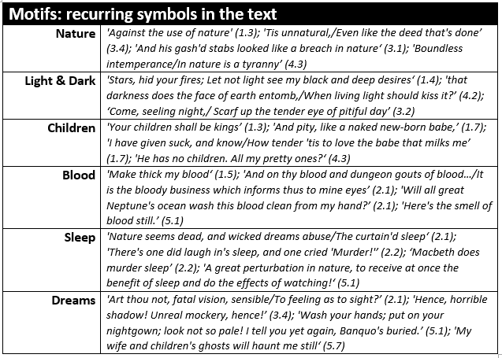

Relevant Vocabulary

Ambition  (noun)  A strong desire to do or achieve something. | Chivalry  (noun)  Bravery, military skill, generosity in victory, courtesy to women | Cowardice  (noun)  Fear and self-concern leading to putting yourself first.
Conflict  (noun)  A serious disagreement or argument. | Desire  (noun)  A strong wish for something or someone. | Duplicity  (noun)  Deceitfulness; being two-faced.
Femininity  (noun)  The quality of being female; womanliness. | Machiavellian  (adjective)  Being cunning, evil and sly. | Masculinity  (noun)  The quality of being male; manliness.
Monarchy  (noun)  The king, queen and royal family of a country. | Paranoia  (noun)  A worry that you are being persecuted or victimised. | Patriarchal  (adjective)  A social system where men (particularly fathers) hold the power and influence.
Prophecy  (noun)  A prediction of the future. | Soliloquy  (noun)  A speech given to the audience. | Superstition  (noun)  A belief in supernatural influences which there are no evidence for.
Tyranny  (noun)  An unfair, unjust and cruel government or rule. | Usurp  (verb)  To take someone else’s place illegally or by force. | Villainy  (noun)  Wicked or criminal behaviour.
Hamartia  (noun)  A fatal flaw leading to the downfall of a tragic hero. | Hubris  (noun)  Excessive pride or confidence. | Catharsis  (noun)  Releasing – and finding release from – strong emotions.

Aristotle’s Elements of a Tragic Hero
Research what this is and write a definition below.
Don’t just copy from the internet – write it in a way you actually understand!
________________________________________________________________________________________________________________________________________________________________________________________________________________________________________________________________________________________________________________________________________________________________________________________________________________________________________________________________________________________________________________________________________________________________________________________________________________________________________________________________________________________________________
Code of Chivalry and Being Chivalrous
The Code of Chivalry was a moral system which went beyond rules of combat and introduced the concept of Chivalrous conduct - qualities idealised by the Medieval knights such as bravery, courtesy, honour and great gallantry toward women. It also incorporated the notion of courtly love. The Code of Chivalry was the honour code of the knight. The Code of Chivalry was an important part of the society and lives of people who lived during the Medieval times and was understood by all.
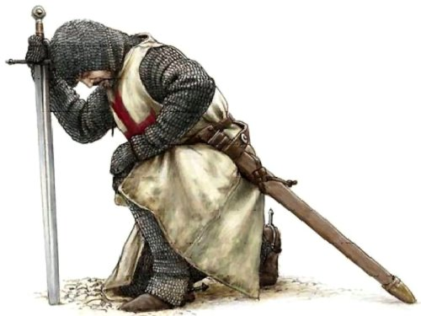
The Knight's Code of Chivalry
A knight was expected to have not only the strength and skills to face combat in the violent era of the Middle Ages but was also expected to temper this aggressive side with a chivalrous side to his nature. The ideals described in the Code of Chivalry were emphasised by the oaths and vows that were sworn in the Knighthood ceremonies of the Middle Ages and the Medieval era. These sacred oaths of combat were combined with the ideals of chivalry and with strict rules of etiquette and codes of conduct towards women.
Code of Chivalry described by the Duke of Burgundy
The chivalric virtues of the Code of Chivalry were also described in the 14th Century by the Duke of Burgundy. The words he chose to use to describe the virtues that should be exhibited in the Knights Code of Chivalry were as follows:

- Faith
- Charity
- Justice
- Prudence
- Resolution
- Truth
- Diligence
- Hope
- Valour

Although Macbeth is a warrior rather than a knight, he would still have been expected to act in a chivalrous fashion. Choose three of the virtues above and explain how Macbeth fails to show them.
1.

2.

3.

King James, Witch Trials and Daemonologie
The North Berwick witch trials were the trials in 1590 of a number of Scottish people accused of witchcraft. They ran for two years and implicated seventy people. The confessions of the ‘witches’ were extracted by torture in Edinburgh.
As King James sailed to Copenhagen to marry Princess Anne of Denmark, a terrible storm hit their ship, causing them to seek shelter in Norway for several weeks. Somehow, this was blamed on various women in Denmark who confessed (probably after being tortured) to raising the storm through sorcery. Two were burned for their crime.
Scottish women were linked to the storms when Gillis Duncan confessed to her employer that she had developed an ability to heal herself. She would also regularly sneak out after dark. She could not explain her strange behaviour, so she was tortured – a result of which was her confession of witchcraft. She accused many others too.
The situation snowballed, with more than a hundred suspects arrested. Under torture, many confessed to meeting with the Devil and devoting themselves to his evil work – including poisoning the king and attempting to sink his ship.
King James established a court hear their trials. Two of the most horrific cases are detailed below...
Agnes Sampson
Sampson was an elderly woman who refused to confess. She suffered horribly – she was fastened to the wall of her cell by a witch’s bridle, an iron instrument with four sharp prongs forced into the mouth, so that two prongs pressed against the tongue, and two others against the cheeks. She was kept without sleep and strangled. Only after these ordeals did she confess to her ‘crimes’. She was hanged and burned as a witch.
Dr John Fian
Like Sampson, he refused to confess to witchcraft. His fingernails were forcibly removed, with iron pins thrust into his fingertips. Thumbscrews are also used to slowly crush his thumbs. A similar device called ‘the boot’ was used to crush his feet. He was finally burned at the stake having confessed.
Influenced by his involvement in the ‘attack’ upon his boat and his role in the subsequent trials, King James wrote his book Daemonologie in 1597.
DAEMONOLOGIE (edited extract)
My intention in this book, is only to prove two things, as I have already said: the one, that such devilish arts exist. The other, what exact trial and severe punishment they deserve: & therefore reason I, what kind of things are possible to be performed in these arts, & by what natural causes they may be, not that I touch every particular thing of the Devil’s power.
I say and prove, that Witches can, by the power of their Master, cure or cast on diseases: Now by these same reasons, that proves their power by the Devil of diseases in generally is as well proved their power in special: as of weakening the nature of some men, to make them unable for women: and making it to abound in others, more then the ordinary course of nature would permit. And such like in all other particular sicknesses.
How do you think what you’ve learned about King James I and Daemonologie influenced Shakespeare’s writing of Macbeth? (AO3)

Eve and the Serpent
God took some clay from the ground and made the shape of a man. Then He breathed gently into the shape. The man's eye's opened and he began to live. God called him Adam.
The Lord made a beautiful garden for him to live in. The garden, called Eden, was full of many wonderful things. Beautiful flowers grew everywhere. Birds sang in the trees, streams flowed through the valley and animals roamed across the fields. God brought all the animals to Adam one at a time to be given their names. "Elephant", he would say, or "Tiger", or "Porcupine".
God had made the man in His image to keep Him company and look after the world. But God felt sorry for Adam. "None of these animals is really like him," thought God, "he needs someone to share his life. Someone who cares for him and who he can care for."
That night, God took a rib from Adam's side and made a woman. When Adam awoke the following morning, he found a wife, Eve, lying asleep beside him. Adam was so happy. He took her hand and she woke up. She looked up at him and smiled.
God told the man and woman that it was their job to take care of their new home. God blessed them, saying, "All this is for you. Help yourself to anything you like. But never touch the tree in the middle of the Garden. That tree gives knowledge of good and evil. The day you eat its fruit, you will die."
God did not mean that Adam and Eve would drop down dead the moment they ate the fruit from the tree. He meant that in time they would die without His Spirit dwelling in them.
One day, Adam and Eve were gathering berries for dinner when she heard a silky voice behind her. "Has God told you that you can eat the fruit from all the trees?" the voice asked softly. Eve turned around to see a snake talking to her.
"God has told us we can eat all the fruit except for what grows on The Tree of the Knowledge of Good and Evil," Eve told the serpent.
"Oh come now, that's silly! I hardly think such a lovely fruit would do you any harm," the serpent lied. "God knows that if you eat from The Tree of the Knowledge of Good and Evil you'll become just like God, and will be able to decide for yourself what is right and what is wrong."
The woman looked at the fruit and thought how tasty it looked. She thought how wonderful it would be to be as wise and powerful as God. She believed the serpent's lie and ate the fruit and also gave some to Adam, who was with her, and he took a bite as well.
She felt a strange feeling in the pit of her stomach. She fidgeted and wondered what was wrong with her. Suddenly she realized that she was feeling guilty - she had disobeyed God and knew she'd done something wrong.
As soon as they ate the fruit a change came over Adam and Eve. They became unhappy and fearful of God.

Adam and Eve heard God calling them. Without thinking, they dived into the bushes, but God knew where they were. When God asked them if they had eaten from The Tree of the Knowledge of Good and Evil that He had told them not to touch, they blamed each other for their sins.
God was sad that Adam and Eve had disobeyed them. He told them that they had to leave the Garden of Eden, "From now on you'll have to scratch a living from the soil. You'll need to make clothes and grow food. Nothing will come easily - not even childbirth. And one day, you will die."
Summarise the story in fifty words or fewer. (AO1)
______________________________________________________________________________________________________________________________________________________________________________________________________________________________________________________________________________________________________________________________________________________________

Original Sin
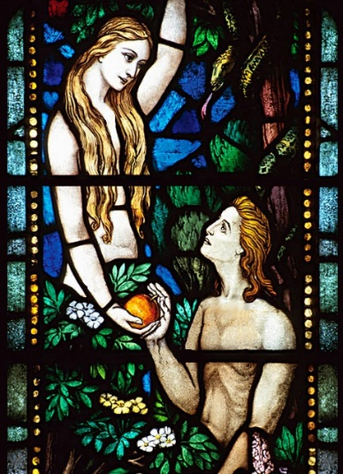
The concept of Original Sin refers generally to the Christian belief in the universal nature of sin. Sin came to the world after Adam and Eve’s behaviour in the Garden of Eden, and Christians believe that ever since that time, all people are born sinful.
Because sin is something we are born with and carry throughout our lives, the only way we can be free of sin is through living good and well-behaved lives.
Christianity would have been far more important in the Jacobean era, and the idea of ‘original sin’ living within us – and being the fault of a woman – would have been common.

What links can you make between the story of the serpent and the story of Macbeth? (AO3)

_____________________________________________________________________________________________________________________________________________________________________________________________________________________________________________________________________________________________________________________________________________________________________________________________________________________________________________________________________________________________________________________________________________________________________________________________________________________________________________________________________________________________________________________________________________________________________________________________

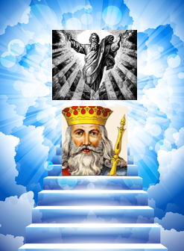
Opinions on Royalty in 1600s
The King or Queen in Shakespeare’s time were considered to be a step down from God. It was believed that God spoke to the monarch. The monarch was the leader, protector, father/mother and the route to heaven. Love and obey your monarch and you will go to heaven. Defy or betray your monarch (TREASON) or kill a king (REGICIDE) and you are killing a God, and you’ll surely go to Hell.

Punishment for Treason
You would be branded a traitor. In Dante’s Inferno (famous pre Macbeth poem) the lowest circle of Hell was reserved for traitors. If you were caught your execution would see you hanged, drawn and quartered. This consisted of hanging till almost dead, then your insides pulled out and your body cut into four pieces. Unless you were a woman, in which case you’d be burnt at the stake.

tyrant (noun)
- A cruel and oppressive ruler who controls his country with absolute power and is not restricted by law.
"the tyrant ruled his people cruelly”
“an evil tyrant who has opposed all who oppose him”
synonyms: dictator; despot; autocrat; absolute ruler; authoritarian; oppressor
Real Life Tyrants
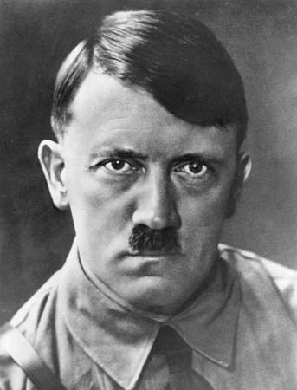 | Adolf Hitler--Nazi dictator of Germany (1933-1945) who originally took office through the German electoral system but quickly threw out the constitution and ruled through force. Responsible for millions of deaths by starting the European portion of World War Two and through the Holocaust, which was an attempt to destroy all Jews in Europe.
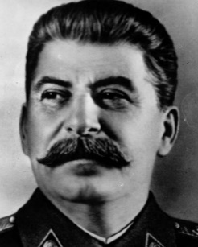 | Joseph Stalin--Soviet dictator (1924-1953). Stalin was a totalitarian ruler, and stayed in power by removing and murdering anyone he thought might be a threat to him. His ideas and policies turned the Soviet Union into a powerful, modern nation, the largest on Earth. It also led to the deaths of millions of people – perhaps as many as 60 million Russians died under his rule.
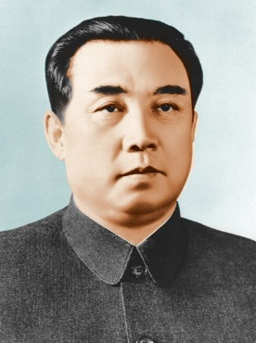 | Kim Jong-Il--Communist dictator of North Korea (1994-2011) Attempted to set up one of his sons to inherit the country upon his passing. Under Jong-Il, North Korea developed nuclear weapons and engaged in dangerous nuclear diplomacy with the U.S, and has engaged in military attacks on South Korea, including the bloody attack on Yeonpyeong Island in 2010.
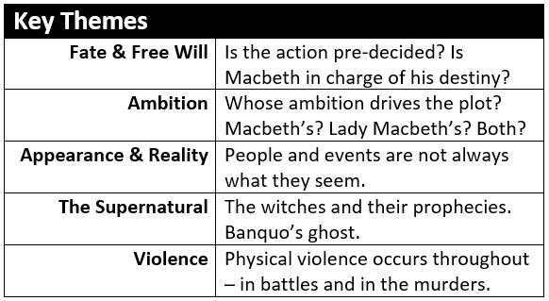

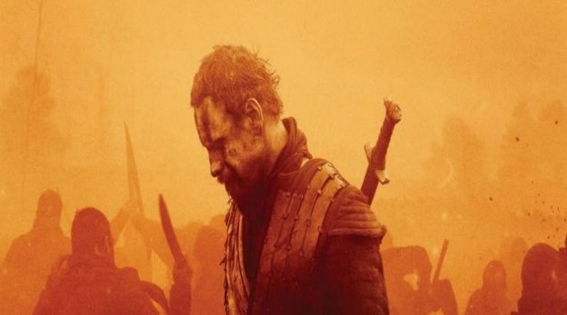

Read the following extract from Act 1, scene 1 then answer the question that follows.
As the play opens, the witches are seen for the first time.

First Witch
When shall we three meet again
In thunder, lightning, or in rain?
Second Witch
When the hurlyburly's done,
When the battle's lost and won.
Third Witch
That will be ere the set of sun.
First Witch
Where the place?
Second Witch
Upon the heath.
Third Witch
There to meet with Macbeth.
First Witch
I come, Graymalkin!
Second Witch
Paddock calls.
Third Witch
Anon.
ALL
Fair is foul, and foul is fair:
Hover through the fog and filthy air.

Starting with this conversation, explain how far you think Shakespeare presents the witches as a powerful force.
Write about
- how Shakespeare presents the witches in this extract;
- how Shakespeare presents the witches in the play as a whole.
30 marks
+ 4 marks AO4

Read the following extract from Act 1, scene 3 then answer the question that follows.
At this point in the play, Macbeth has just been told that he is to be the new Thane of Cawdor: the second of the witches’ prophesies has come true.

MACBETH
[Aside] Two truths are told,
As happy prologues to the swelling act
Of the imperial theme.--I thank you, gentlemen.
(Aside) This supernatural soliciting
Cannot be ill, cannot be good: if ill,
Why hath it given me earnest of success,
Commencing in a truth? I am thane of Cawdor:
If good, why do I yield to that suggestion
Whose horrid image doth unfix my hair
And make my seated heart knock at my ribs,
Against the use of nature? Present fears
Are less than horrible imaginings:
My thought, whose murder yet is but fantastical,
Shakes so my single state of man that function
Is smother'd in surmise, and nothing is
But what is not.

Starting with this speech, explain how far you think Shakespeare presents Macbeth’s conflicted state of mind.
Write about
- how Shakespeare presents Macbeth in this extract;
- how Shakespeare presents Macbeth in the play as a whole.
30 marks
+ 4 marks AO4

Read the following extract from Act 1, scene 4 then answer the question that follows.
At this point in the play, Duncan is thinking about the traitor, the Thane of Cawdor, while he waits for the arrival of his new Thane of Cawdor, Macbeth.

DUNCAN
There's no art
To find the mind's construction in the face:
He was a gentleman on whom I built
An absolute trust.
Enter MACBETH, BANQUO, ROSS, and ANGUS
O worthiest cousin!
The sin of my ingratitude even now
Was heavy on me: thou art so far before
That swiftest wing of recompense is slow
To overtake thee. Would thou hadst less deserved,
That the proportion both of thanks and payment
Might have been mine! only I have left to say,
More is thy due than more than all can pay.
MACBETH
The service and the loyalty I owe,
In doing it, pays itself. Your highness' part
Is to receive our duties; and our duties
Are to your throne and state children and servants,
Which do but what they should, by doing every thing
Safe toward your love and honour.

Starting with this conversation, explain how far you think Shakespeare presents ideas of loyalty.
Write about
- how Shakespeare presents loyalty in this extract;
- how Shakespeare presents loyalty in the play as a whole.
30 marks
+ 4 marks AO4

Read the following extract from Act 1, scene 5 then answer the question that follows.
At this point in the play, Macbeth has just returned to his wife after being given the witches’ predictions.

MACBETH
My dearest love,
Duncan comes here to-night.
LADY MACBETH
And when goes hence?
MACBETH
To-morrow, as he purposes.
LADY MACBETH
O, never
Shall sun that morrow see!
Your face, my thane, is as a book where men
May read strange matters. To beguile the time,
Look like the time; bear welcome in your eye,
Your hand, your tongue: look like the innocent flower,
But be the serpent under't. He that's coming
Must be provided for: and you shall put
This night's great business into my dispatch;
Which shall to all our nights and days to come
Give solely sovereign sway and masterdom.
MACBETH
We will speak further.
LADY MACBETH
Only look up clear;
To alter favour ever is to fear:
Leave all the rest to me.

Starting with this conversation, explain how far you think Shakespeare presents Lady Macbeth.
Write about
- how Shakespeare presents Lady Macbeth in this extract;
- how Shakespeare presents Lady Macbeth in the play as a whole.
30 marks
+ 4 marks AO4

Read the following extract from Act 1 Scene 5 of Macbeth and then answer the question that follows. At this point in the play Lady Macbeth is awaiting the arrival of King Duncan at her home.

LADY MACBETH
The raven himself is hoarse
That croaks the fatal entrance of Duncan
Under my battlements. Come, you spirits
That tend on mortal thoughts, unsex me here,
And fill me from the crown to the toe top-full
Of direst cruelty. Make thick my blood,
Stop up th’access and passage to remorse,
That no compunctious visitings of nature
Shake my fell purpose, nor keep peace between
Th’ effect and it. Come to my woman’s breasts,
And take my milk for gall, you murd’ring ministers,
Wherever in your sightless substances
You wait on nature’s mischief. Come, thick night,
And pall thee in the dunnest smoke of hell,
That my keen knife see not the wound it makes,
Nor heaven peep through the blanket of the dark,
To cry ‘Hold, hold!’

Starting with this speech, explain how far you think Shakespeare presents Lady Macbeth the driving force for the murder of King Duncan.
Write about:
- How Shakespeare presents Lady Macbeth is this speech.
- How Shakespeare presents Lady Macbeth in the play as a whole.

Read the following extract from Act 1 Scene 7 of Macbeth and then answer the question that follows. At this point in the play Macbeth is debating if he should kill King Duncan.

MACBETH
If it were done when ’tis done, then ’twere well
It were done quickly. If th’assassination
Could trammel up the consequence, and catch
With his surcease success: that but this blow
Might be the be-all and the end-all, here,
But here upon this bank and shoal of time,
We’d jump the life to come. But in these cases
We still have judgement here, that we but teach
Bloody instructions which, being taught, return
To plague th’inventor. This even-handed justice
Commends th’ingredience of our poisoned chalice
To our own lips. He’s here in double trust:
First, as I am his kinsman and his subject,
Strong both against the deed; then, as his host,
Who should against his murderer shut the door,
Not bear the knife myself.

Starting with this speech, explain how far you think Macbeth is presented as a character who abandons his sense of right and wrong.
Write about:
- How Shakespeare presents Macbeth is this speech.
- How Shakespeare presents Macbeth in the play as a whole.

[30 marks]

Read the following extract from Act 1, scene 7 then answer the question that follows.
At this point in the play, Macbeth says he will not murder Duncan. Lady Macbeth reacts to his change of heart.

LADY MACBETH
What beast was't, then,
That made you break this enterprise to me?
When you durst do it, then you were a man;
And, to be more than what you were, you would
Be so much more the man. Nor time nor place
Did then adhere, and yet you would make both:
They have made themselves, and that their fitness now
Does unmake you. I have given suck, and know
How tender 'tis to love the babe that milks me:
I would, while it was smiling in my face,
Have pluck'd my nipple from his boneless gums,
And dash'd the brains out, had I so sworn as you
Have done to this.
MACBETH
If we should fail?
LADY MACBETH
We fail!
But screw your courage to the sticking-place,
And we'll not fail.

Starting with this conversation, explain how far you think Shakespeare presents Lady Macbeth as dominant.
Write about
- how Shakespeare presents Lady Macbeth in this extract;
- how Shakespeare presents Lady Macbeth in the play as a whole.
30 marks
+ 4 marks AO4

Read the following extract from Act 2, scene 2 then answer the question that follows.
At this point in the play, Duncan has been murdered. Macbeth and Lady Macbeth are in the next room, both with blood on their hands.

LADY MACBETH
My hands are of your colour; but I shame
To wear a heart so white.
Knocking within
I hear a knocking
At the south entry: retire we to our chamber;
A little water clears us of this deed:
How easy is it, then! Your constancy
Hath left you unattended.
Knocking within
Hark! more knocking.
Get on your nightgown, lest occasion call us,
And show us to be watchers. Be not lost
So poorly in your thoughts.
MACBETH
To know my deed, 'twere best not know myself.
Knocking within
Wake Duncan with thy knocking! I would thou couldst!

Starting with this conversation, explain how far you think Shakespeare presents Lady Macbeth as in control.
Write about
- how Shakespeare presents Lady Macbeth in this extract;
- how Shakespeare presents Lady Macbeth in the play as a whole.
30 marks
+ 4 marks AO4

Read the following extract from Act 3, scene 1.
Macbeth, now King, is alone, remembering the witches’ prophecies.

To be thus is nothing;
But to be safely thus.--Our fears in Banquo
Stick deep; and in his royalty of nature
Reigns that which would be fear'd: 'tis much he dares;
And, to that dauntless temper of his mind,
He hath a wisdom that doth guide his valour
To act in safety. There is none but he
Whose being I do fear: and, under him,
My Genius is rebuked; as, it is said,
Mark Antony's was by Caesar. He chid the sisters
When first they put the name of king upon me,
And bade them speak to him: then prophet-like
They hail'd him father to a line of kings:
Upon my head they placed a fruitless crown,
And put a barren sceptre in my gripe,
Thence to be wrench'd with an unlineal hand,
No son of mine succeeding. If 't be so,
For Banquo's issue have I filed my mind;
For them the gracious Duncan have I murder'd;
Put rancours in the vessel of my peace
Only for them; and mine eternal jewel
Given to the common enemy of man,
To make them kings, the seed of Banquo kings!

Starting with this speech, explain how far you think Shakespeare presents Macbeth as troubled.
Write about
- how Shakespeare presents Macbeth in this extract;
- how Shakespeare presents Macbeth in the play as a whole.
30 marks
+ 4 marks AO4

Read the following extract from Act 3, scene 2 then answer the question that follows.
At this point in the play, Macbeth and Lady Macbeth are worrying that despite murdering Duncan, they are not secure as King and Queen.

LADY MACBETH
Nought's had, all's spent,
Where our desire is got without content:
'Tis safer to be that which we destroy
Than by destruction dwell in doubtful joy.
Enter MACBETH
How now, my lord! why do you keep alone,
Of sorriest fancies your companions making,
Using those thoughts which should indeed have died
With them they think on? Things without all remedy
Should be without regard: what's done is done.
MACBETH
We have scotch'd the snake, not kill'd it:
She'll close and be herself, whilst our poor malice
Remains in danger of her former tooth.
But let the frame of things disjoint, both the
worlds suffer,
Ere we will eat our meal in fear and sleep
In the affliction of these terrible dreams
That shake us nightly: better be with the dead,
Whom we, to gain our peace, have sent to peace,
Than on the torture of the mind to lie
In restless ecstasy.

Starting with this conversation, explain how far you think Shakespeare presents Macbeth and Lady Macbeth’s relationship.
Write about
- how Shakespeare presents Macbeth and Lady Macbeth’s relationship in this extract;
- how Shakespeare presents Macbeth and Lady Macbeth’s relationship in the play as a whole.
30 marks
+ 4 marks AO4

Read the following extract from Act 3, scene 4 then answer the question that follows.
At this point in the play, Banquo’s ghost appears to Macbeth as he is attending his first banquet as king.

MACBETH
Avaunt! and quit my sight! let the earth hide thee!
Thy bones are marrowless, thy blood is cold;
Thou hast no speculation in those eyes
Which thou dost glare with!
LADY MACBETH
Think of this, good peers,
But as a thing of custom: 'tis no other;
Only it spoils the pleasure of the time.
MACBETH
What man dare, I dare:
Approach thou like the rugged Russian bear,
The arm'd rhinoceros, or the Hyrcan tiger;
Take any shape but that, and my firm nerves
Shall never tremble: or be alive again,
And dare me to the desert with thy sword;
If trembling I inhabit then, protest me
The baby of a girl. Hence, horrible shadow!
Unreal mockery, hence!
GHOST OF BANQUO vanishes
Why, so: being gone,
I am a man again. Pray you, sit still.

Starting with this conversation, explain how far you think Shakespeare presents Macbeth’s changing feelings.
Write about
- how Shakespeare presents Macbeth in this extract;
- how Shakespeare presents Macbeth in the play as a whole.
30 marks
+ 4 marks AO4

Read the following extract from Act 4, scene 1 then answer the question that follows.
At this point in the play, Macbeth has gone to consult the witches.

MACBETH
How now, you secret, black, and midnight hags!
What is't you do?
ALL
A deed without a name.
MACBETH
I conjure you, by that which you profess,
Howe'er you come to know it, answer me:
Though you untie the winds and let them fight
Against the churches; though the yesty waves
Confound and swallow navigation up;
Though bladed corn be lodged and trees blown down;
Though castles topple on their warders' heads;
Though palaces and pyramids do slope
Their heads to their foundations; though the treasure
Of nature's germens tumble all together,
Even till destruction sicken; answer me
To what I ask you.
First Witch
Speak.
Second Witch
Demand.
Third Witch
We'll answer.

Starting with this conversation, explain how far you think Shakespeare presents the supernatural.
Write about
- how Shakespeare presents the supernatural in this extract;
- how Shakespeare presents the supernatural in the play as a whole.
30 marks
+ 4 marks AO4

Read the following extract from Act 4, scene 3.
Macduff has just heard of the murder of his wife and children. He is speaking with Malcolm.

MALCOLM
Be this the whetstone of your sword: let grief
Convert to anger; blunt not the heart, enrage it.
MACDUFF
O, I could play the woman with mine eyes
And braggart with my tongue! But, gentle heavens,
Cut short all intermission; front to front
Bring thou this fiend of Scotland and myself;
Within my sword's length set him; if he 'scape,
Heaven forgive him too!
MALCOLM
This tune goes manly.
Come, go we to the king; our power is ready;
Our lack is nothing but our leave; Macbeth
Is ripe for shaking, and the powers above
Put on their instruments. Receive what cheer you may:
The night is long that never finds the day.

Starting with this conversation, explain how far you think Shakespeare presents Malcolm.
Write about
- how Shakespeare presents Malcolm in this extract;
- how Shakespeare presents Malcolm in the play as a whole.
30 marks
+ 4 marks AO4

Read the following extract from Act 5, scene 1 then answer the question that follows.
At this point in the play, Lady Macbeth is sleep-walking while her doctor and gentlewoman watch.

LADY MACBETH
Out, damned spot! out, I say!--One: two: why,
then, 'tis time to do't.--Hell is murky!--Fie, my
lord, fie! a soldier, and afeard? What need we
fear who knows it, when none can call our power to
account?--Yet who would have thought the old man
to have had so much blood in him.
Doctor
Do you mark that?
LADY MACBETH
The thane of Fife had a wife: where is she now?--
What, will these hands ne'er be clean?--No more o'
that, my lord, no more o' that: you mar all with
this starting.
Doctor
Go to, go to; you have known what you should not.
Gentlewoman
She has spoke what she should not, I am sure of
that: heaven knows what she has known.
LADY MACBETH
Here's the smell of the blood still: all the
perfumes of Arabia will not sweeten this little
hand. Oh, oh, oh!

Starting with this conversation, explain how far you think Shakespeare presents Lady Macbeth’s feelings.
Write about
- how Shakespeare presents Lady Macbeth in this extract;
- how Shakespeare presents Lady Macbeth in the play as a whole.
30 marks
+ 4 marks AO4

Read the following extract from Act 5 Scene 3 of Macbeth and then answer the question that follows. At this point in the play Macbeth is under siege from the English army.

MACBETH
Bring me no more reports; let them fly all:
Till Birnam wood remove to Dunsinane,
I cannot taint with fear. What's the boy Malcolm?
Was he not born of woman? The spirits that know
All mortal consequences have pronounced me thus:
'Fear not, Macbeth; no man that's born of woman
Shall e'er have power upon thee.' Then fly, false thanes,
And mingle with the English epicures:
The mind I sway by and the heart I bear
Shall never sag with doubt nor shake with fear.
Enter a Servant

The devil damn thee black, thou cream-faced loon!
Where got'st thou that goose look?

Starting with this speech, explain how far you think Shakespeare presents Macbeth as a hero.
Write about:
- How Shakespeare presents Macbeth is this speech.
- How Shakespeare presents Macbeth in the play as a whole.
[30 marks]
AO4 [4 marks]

Read the following extract from Act 5, scene 8 then answer the question that follows.
At this point in the play, Macbeth is still confident that he cannot be killed by anyone born from a woman.

MACDUFF
Turn, hell-hound, turn!
MACBETH
Of all men else I have avoided thee:
But get thee back; my soul is too much charged
With blood of thine already.
MACDUFF
I have no words:
My voice is in my sword: thou bloodier villain
Than terms can give thee out!
They fight
MACBETH
Thou losest labour:
As easy mayst thou the intrenchant air
With thy keen sword impress as make me bleed:
Let fall thy blade on vulnerable crests;
I bear a charmed life, which must not yield,
To one of woman born.
MACDUFF
Despair thy charm;
And let the angel whom thou still hast served
Tell thee, Macduff was from his mother's womb
Untimely ripp'd.

Starting with this conversation, explain how far you think Shakespeare presents Macbeth as feeling protected.
Write about
- how Shakespeare presents Macbeth in this extract;
- how Shakespeare presents Macbeth in the play as a whole.
30 marks
+ 4 marks AO4

Read the following extract from Act 5, scene 8 then answer the question that follows.
At this point in the play, Macbeth has been killed. Malcolm is preparing to take his rightful place as king.

MALCOLM
We shall not spend a large expense of time
Before we reckon with your several loves,
And make us even with you. My thanes and kinsmen,
Henceforth be earls, the first that ever Scotland
In such an honour named. What's more to do,
Which would be planted newly with the time,
As calling home our exiled friends abroad
That fled the snares of watchful tyranny;
Producing forth the cruel ministers
Of this dead butcher and his fiend-like queen,
Who, as 'tis thought, by self and violent hands
Took off her life; this, and what needful else
That calls upon us, by the grace of Grace,
We will perform in measure, time and place:
So, thanks to all at once and to each one,
Whom we invite to see us crown'd at Scone.

Starting with this conversation, explain how far you think Shakespeare presents Malcolm.
Write about
- how Shakespeare presents Malcolm in this extract;
- how Shakespeare presents Malcolm in the play as a whole.
30 marks
+ 4 marks AO4

English Literature, Paper 1 and 2
(30 marks – AO1=12, AO2=12, AO3=6)
Levels | AO | Skills
Level 6  26-30 marks | AO1 | - Critical, exploratory, conceptualised response to task and whole text  - Judicious use of precise references to support interpretation(s)
Level 6  26-30 marks | AO2 | - Analysis of writer’s methods with subject terminology used judiciously  - Exploration of effects of writer’s methods on reader
Level 6  26-30 marks | AO3 | - Exploration of ideas/perspectives/contextual factors shown by specific, detailed links between context/text/task
Level 5  21-25 marks | AO1 | - Thoughtful, developed response to task and whole text  - Apt references integrated into interpretation(s)
Level 5  21-25 marks | AO2 | - Examination of writer’s methods with subject terminology used effectively to support consideration of methods  - Examination of effects of writer’s methods on reader
Level 5  21-25 marks | AO3 | - Thoughtful consideration of ideas/perspectives/contextual factors shown by examination of detailed links between context/text/task
Level 4  16-20 marks | AO1 | - Clear, explained response to the task and whole text   - Effective use of references to support explanation
Level 4  16-20 marks | AO2 | - Clear explanation of writer’s methods with appropriate use of relevant subject terminology  - Understanding of effects of writer’s methods on reader
Level 4  16-20 marks | AO3 | - Clear understanding of ideas/perspectives/ contextual factors shown by specific links between context/text/task
Level 3  11-15 marks | AO1 | - Some explained response to task and whole text  - References used to support a range of relevant comments
Level 3  11-15 marks | AO2 | - Explained/relevant comments on writer’s methods with some relevant use of subject terminology  - Identification of effects of writer’s methods on reader
Level 3  11-15 marks | AO3 | - Some understanding of implicit ideas/ perspectives/contextual factors shown by links between context/text/task
Level 2  6-10 marks | AO1 | - Supported response to task and text  - Comments on references
Level 2  6-10 marks | AO2 | - Identification of writers’ methods  - Some reference to subject terminology
Level 2  6-10 marks | AO3 | - Some awareness of implicit ideas/contextual factors
Level 1  1-5 marks | AO1 | - Simple comments relevant to task and text  - Reference to relevant details
Level 1  1-5 marks | AO2 | - Awareness of writer making deliberate choices  - Possible reference to subject terminology
Level 1  1-5 marks | AO3 | - Simple comment on explicit ideas/contextual factors
High  In the context of the level of demand of the question, learners spell and punctuate with consistent accuracy, and consistently use vocabulary and sentence structures to achieve effective control of meaning. | 4
Intermediate performance:  In the context of the level of demand of the question, learners spell and punctuate with considerable accuracy, and use a considerable range of vocabulary and sentence structures to achieve general control of meaning. | 2-3
Threshold performance:  In the context of the level of demand of the question, learners spell and punctuate with reasonable accuracy, and use a reasonable range of vocabulary and sentence structures; any errors do not hinder meaning in the response. | 1

AO4 Paper 1 and 2: Section A

