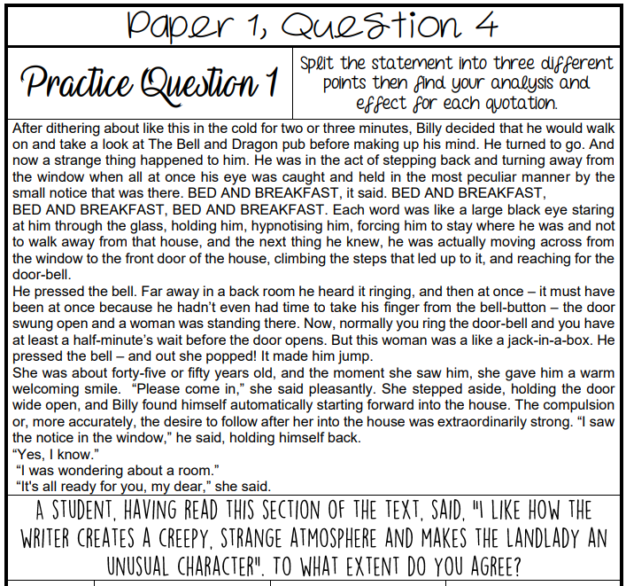
What can I write about/ include? (Think methods)
Topic Sentence for each section:
Thesis – how far do you agree with the statement? Big ideas:
PEZAL 1:

Link PEZAL 2:

Link PEZAL 3:

Conclude:

- Response to statement Range of textual detail
- Understanding of methods Critical, detailed evaluation of the effect(s) on the reader
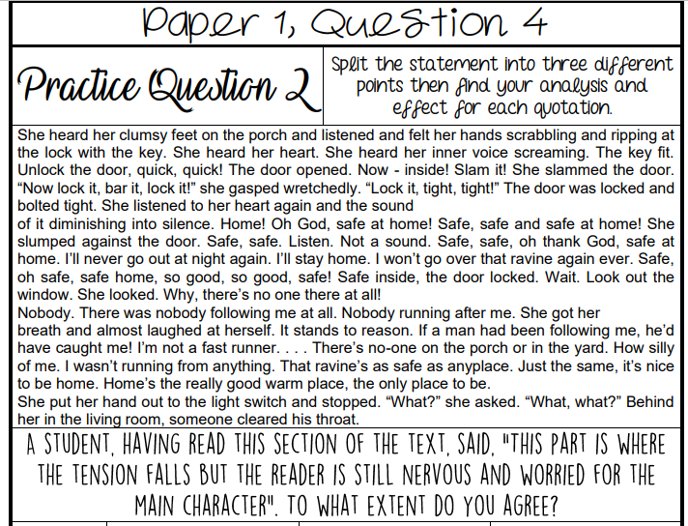
What can I write about/ include? (Think methods)
Topic Sentence for each section:
Thesis – how far do you agree with the statement? Big ideas:
PEZAL 1:

Link PEZAL 2:

Link PEZAL 3:

Conclude:

- Response to statement Range of textual detail
- Understanding of methods Critical, detailed evaluation of the effect(s) on the reader

