Paper 1, Q5 Final Push
Task 1- Read the extract/ Q2. List 3 adjectives to describe the mood/tone being created:
……………………………………………………………………………………………………………………
- Highlight and annotate 3 images/ moments that describe the house/ support the mood/tone identified above.
- For each one, annotate with your inference and circle the word you would zoom in on. Label any devices.
- Tonight: write up your Q2 response.
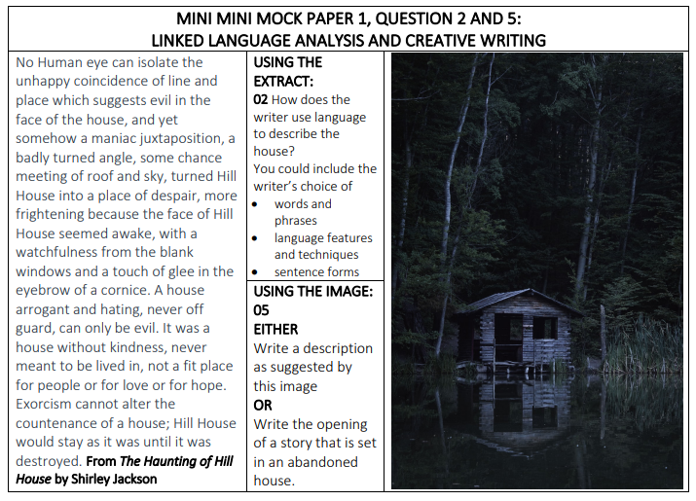
Task 2 – Now look to Q5 and follow the steps below:
Step 1. Read / select your Q choice.
Step 2. Jot down initial thoughts /ideas around the outside. These will be your best ideas.
Step 3. Plan out below what you will write about, in what order. What will your motif be?
Motif = …………………… | The what (events): | The how (techniques)
- Drop

- Shift

- Zoom

- Link

Step 4 : Start writing

……………………………………………………………………………………………………………………
……………………………………………………………………………………………………………………
……………………………………………………………………………………………………………………
……………………………………………………………………………………………………………………
……………………………………………………………………………………………………………………
……………………………………………………………………………………………………………………
……………………………………………………………………………………………………………………
……………………………………………………………………………………………………………………
……………………………………………………………………………………………………………………
……………………………………………………………………………………………………………………
……………………………………………………………………………………………………………………
……………………………………………………………………………………………………………………
……………………………………………………………………………………………………………………
……………………………………………………………………………………………………………………
……………………………………………………………………………………………………………………
……………………………………………………………………………………………………………………
……………………………………………………………………………………………………………………
……………………………………………………………………………………………………………………
……………………………………………………………………………………………………………………
……………………………………………………………………………………………………………………
……………………………………………………………………………………………………………………
……………………………………………………………………………………………………………………
……………………………………………………………………………………………………………………
……………………………………………………………………………………………………………………
……………………………………………………………………………………………………………………
……………………………………………………………………………………………………………………
……………………………………………………………………………………………………………………
……………………………………………………………………………………………………………………
……………………………………………………………………………………………………………………
……………………………………………………………………………………………………………………

Step 5: Check –SPAG / Paragraphing (VARIETY)

