English Department
AQA GCSE English Literature
Worlds and Lives Essential Revision Guide, Part 2


Finham Park 2
English Department
Name: …………………………..

Cluster Three: Nature and the Environment
In this cluster, the poems are linked through the speaker connecting to their environments around them. In this cluster, we meet Romantic poets who rebel against industrialisation and critique humanity’s drive for progress, whilst in other poems exploring the role of our senses in appreciating and connecting with our environments.

Comparative Questions to consider in this cluster:
- What role does mankind play in the connection with the natural world?
- How much has industrialisation affected relationships with the natural world?
- What role do the senses play in connecting humankind with nature?
- Who has power: man or nature? Or is it a codependent relationship?

- England in 1819 by Percy Shelley

An old, mad, blind, despised, and dying King;
Princes, the dregs of their dull race, who flow
Through public scorn,—mud from a muddy spring;
Rulers who neither see nor feel nor know,
But leechlike to their fainting country cling
Till they drop, blind in blood, without a blow.
A people starved and stabbed in th' untilled field;
An army, whom liberticide and prey
Makes as a two-edged sword to all who wield;
Golden and sanguine laws which tempt and slay;
Religion Christless, Godless—a book sealed;
A senate, Time’s worst statute, unrepealed—
Are graves from which a glorious Phantom may
Burst, to illumine our tempestuous day.

Glossary:
- Dregs – the most worthless part/parts of something​
- Leechlike – like a leech (a blood sucking creature) or clinging, like a parasite.​
- Untilled – not cultivated or worked to raise crops ​
- Liberticide – Destroyer of liberty/freedom​
- Sanguine – positive, hopeful​
- Illumine – to light up, brighten.​
- Tempestuous- very stormy​

Summary:
The speaker voices outrage at his country’s corruption, through its monarchy, army and the Church.It also insists that this decay could offer hope for a phoenix-like rebirth. England might be in terrible disorder,, but the collapse of the old system of monarchical rule is also the chance for a visionary new beginning.

Key Context:
- Shelley a Romantic poet, exploring the fragility of power and criticising ‘THE ESTABLISHMENT’ : structures in society such as the government and monarchy who they believed abused their power.​
- It is believed this poem was written in response to the Peterloo Massacre, an event where during a peaceful protest, the cavalry were ordered to charge at the crowd.​
- The monarch of the time, George III, was criticised for his inept ruling of the country and bouts of insanity.​

Form and Structure:
​"England in 1819" is a sonnet that combines several conventions of the English and Italian sonnets. Traditionally, both kinds of sonnet are 14 lines long and, when written in English, use iambic pentameter.
Italian sonnets consist of an eight-line stanza called an octave followed by a six-line stanza called a sestet. Based on its rhyme scheme, "England in 1819" looks like a flipped Italian sonnet, with a sestet followed by an octave; lines 1-6 feature one pair of rhyme sounds, while lines 7-14 feature a different pair of rhyme sounds.
A couple of features of the English sonnet are also mixed in. For example, the poem opens with four lines in an ABAB rhyme pattern, as is typical of an English sonnet. The poem also features a turn, or volta, in its closing couplet, where the poem's argument shifts; here, the speaker moves from talking about England's destruction to its potential rebirth.
Shelley's decision to blend the English and Italian forms may relate to the fact that he was writing about England while in Italy. His decision to flip the octave and the sestet mirrors the chaos he's writing about. The world of England in 1819 seems to have turned upside down, so the form reflects this.
Shelley's choice of rhyme scheme in this sonnet is highly unusual."England in 1819" rhymes as follows: ABABAB CDCDCCDD. The rhymes mark a sestet followed by an octave—and at the end of this octave is a couplet. The poem thus combines and plays with both the Italian and English sonnet schemes. This inverted, unexpected structure seems to fit Shelley's depiction of a world gone topsy-turvy. The mashup of rhyme schemes may also be a sly joke, reflecting his status as an Englishman writing about England from Italy.

Key Language Analysis Quotations:
1.An old, mad, blind, despised, and dying King; Princes, the dregs of their dull race
2.A people starved and stabbed in th’ untilled field;/An army, whom liberticide and prey​/Makes as a two-edged sword to all who wield
3.a glorious Phantom may / Burst, to illumine our tempestuous day

Helpful Revision Links:
https://youtu.be/UOO2BlfdgqU?si=08wY4QwxTpAP0kVy Mr Bruff Analysis
https://youtu.be/uFXNwK7YWSo?si=RlA-VWZsiDUnIALY First Rate Tutors Analysis
https://www.thenational.academy/pupils/programmes/english-secondary-year-10-aqa/units/poetry-anthology-first-study-199/lessons/understanding-the-poem-england-in-1819-e2428/overview Oak Academy Intro
https://www.thenational.academy/pupils/programmes/english-secondary-year-10-aqa/units/poetry-anthology-first-study-199/lessons/analysing-the-poem-england-in-1819-b2429/overview Oak Academy Analysis

2. Shall Earth No More Inspire Thee by Emily Bronte
Shall earth no more inspire thee,​
Thou lonely dreamer now?​
Since passion may not fire thee​
Shall Nature cease to bow?​
​
Thy mind is ever moving​
In regions dark to thee;​
Recall its useless roving—​
Come back and dwell with me.​

I know my mountain breezes​
Enchant and soothe thee still—​
I know my sunshine pleases​
Despite thy wayward will.​
​
When day with evening blending​
Sinks from the summer sky,​
I’ve seen thy spirit bending​
In fond idolatry.​

I’ve watched thee every hour;​
I know my mighty sway,​
I know my magic power​
To drive thy griefs away.​
​
Few hearts to mortals given​
On earth so wildly pine; ​
Yet none would ask a heaven ​
More like this earth than thine.​

Then let my winds caress thee; ​
Thy comrade let me be—​
Since nought beside can bless thee,​
Return and dwell with me.​

Glossary:
Thee/Thou – you / Thy/thine – your(s)​
Cease – stop​
Regions – places/areas​
Roving – constantly moving between places​
dwell – live/stay​
Enchant – interest, put under a spell​
Wayward – difficult to control/predict​
Idolatry – worshipping a false God​
Mortal – someone who is human, who can die​
Pine – to want or long for something​
Caress – hold, touch​
Comrade – someone who supports you​
Nought – no one, nothing​

Summary:
n this poem, the earth itself reaches out to a "lonely dreamer": a person who has in the past found deep delight in nature, but has since withdrawn into a melancholy solitude. Only nature, the earth tells this dreamer, can heal them; they'll only get lost if they look for answers in their own inner world. Nature, in this poem, is more than just a beautiful place. It's a godlike person, eager to share an intense relationship with those who open themselves to its powers.

Key Context:
- Brontë is writing at a similar time to the Romantic poets- shared themes of praise of the beauty and power of nature.​
- She is a Victorian poet, witnessing the effect of the Industrial Revolution on natural spaces.​
- Brontë, dying young from Tuberculosis, enjoyed nothing more than wandering around the moors (fields with long grass) where she grew up – refusing all treatment.
- In many ways, Emily Brontë would live in a private otherworld her whole life. On those few occasions she traveled away from home (to attend school alongside Charlotte, for instance), she hated it. She was always most at ease in the seclusion of her native Yorkshire, roaming the moors with her beloved dog Keeper. The daughter of a minister, Brontë developed her own nonconformist and individual relationship to God: like the "lonely dreamer" of this poem, she found comfort, inspiration, and divinity in nature.

Form and Structure:
“Shall earth no more inspire thee” uses an urgent, simple form that suits its passionate speaker: the earth itself. The poem’s seven quatrains (four-line stanzas) are all written in iambic trimeter. This means the stress is on the second syllable each time in a six syllable line.
The stanzas also follow an ABAB rhyme scheme.
This simple form echoes that of a ballad, and nothing feels fussy or elegant in this poem's shape; the rhymes and rhythms move like firm, even footsteps or a pulsing heartbeat. That energy perfectly matches what the earth is calling its wandering beloved to do: get back on their feet, get their blood pumping, and get back into nature.

Key Language Analysis Quotations:
1.Shall earth no more inspire thee,​/Thou lonely dreamer now?​/Since passion may not fire thee​/ Shall Nature cease to bow?​
2.I know my sunshine pleases​/Despite thy wayward will.​
3. I know my mighty sway,​/I know my magic power​/To drive thy griefs away.​
4.Thy comrade let me be—​/Since nought beside can bless thee,​/ Return and dwell with me.​

Helpful Revision Links:
https://www.youtube.com/watch?v=97srTOLk9rM&list=PLuFWDYRTijJu0NlemxZytCB4uPAoyKBmG&index=8 First Rate Tutors Analysis
https://www.thenational.academy/pupils/programmes/english-secondary-year-10-aqa/units/poetry-anthology-first-study-199/lessons/understanding-the-poem-shall-earth-no-more-inspire-thee/overview Oak Academy Intro
https://www.thenational.academy/pupils/programmes/english-secondary-year-10-aqa/units/poetry-anthology-first-study-199/lessons/analysing-the-poem-shall-earth-no-more-inspire-thee/overview Oak Academy Analysis

3. Lines Written in Early Spring by William Wordsworth

I heard a thousand blended notes,
While in a grove I sate reclined,
In that sweet mood when pleasant thoughts
Bring sad thoughts to the mind.

To her fair works did Nature link
The human soul that through me ran;
And much it grieved my heart to think
What man has made of man.

Through primrose tufts, in that green bower,
The periwinkle trailed its wreaths;
And ’tis my faith that every flower
Enjoys the air it breathes.

he birds around me hopped and played,
Their thoughts I cannot measure:—
But the least motion which they made
It seemed a thrill of pleasure.
The budding twigs spread out their fan,
To catch the breezy air;
And I must think, do all I can,
That there was pleasure there.

If this belief from heaven be sent,
If such be Nature’s holy plan,
Have I not reason to lament
What man has made of man?

Glossary:
- grove : a collection of trees, like a wood.
- grieved: felt intense sorrow/sadness.
- periwinkle: a blueish, flowering plant.
- budding: growing flower buds.
- lament: to express your grief or sadness

Summary:
The speaker reflects on the harmony and healing power of nature. He then laments and is critical of humanity for failing to take nature’s example of peace, serenity and unity.

Key Context:
The Romantic Poets:
- celebrated and revered nature AND criticised structures in society they believed restricted freedom and abused their power.
- They advocated for social change and criticised the impact of the Industrial Revolution
- "Lines Written in Early Spring" is a poem from one of Wordsworth's most important works: Lyrical Ballads, a collaborative volume he wrote with his close friend (and fellow poet) Samuel Taylor Coleridge.

Form and Structure:
The 24 lines of "Lines Written in Early Spring" are broken up into six stanzas, each containing four lines (making them quatrains). These are also ballad stanzas—meaning they follow a simple ABAB rhyme scheme and have a specific meter
"Lines Written in Early Spring" is actually not just a ballad, but a lyrical ballad—meaning its pleasing form is meant to beautifully reflect the speaker's emotion.
Regular stanzas/line lengths, the calm and secure presentation of the power of nature.

Key Language Analysis Quotations:
1.I heard a thousand blended notes,/While in a grove I sate reclined,/ In that sweet mood when pleasant thoughts/Bring sad thoughts to the mind.
2.he human soul that through me ran;/And much it grieved my heart to think/ What man has made of man.
3.And ’tis my faith that every flower/Enjoys the air it breathes.
4.Have I not reason to lament/What man has made of man?
Helpful Revision Links:
https://youtu.be/2MMb9JS5u0U?si=d2thbCdRRGWpU0UQ: First Rate Tutors Analysis
https://www.youtube.com/watch?v=7wYxCNwZ38k Mr Bruff Analysis
https://www.thenational.academy/pupils/programmes/english-secondary-year-10-aqa/units/poetry-anthology-first-study-199/lessons/understanding-the-poem-lines-written-in-early-spring/overview Oak Academy Intro
https://www.thenational.academy/pupils/programmes/english-secondary-year-10-aqa/units/poetry-anthology-first-study-199/lessons/analysing-the-poem-lines-written-in-early-spring/overview Oak Academy Analysis

4. With Birds You’re Never Lonely by Raymond Antrobus

I can’t hear the barista​
over the coffee machine.​
​
Spoons slam, steam rises.​
I catch the eye of a man​
​
sitting in the corner​
of the cafe reading alone​
​
about trees which is, incidentally,​
all I can think about​
​
since returning.​
Last week I sat alone​
​
on a stump, deep in Zelandia forest​
with sun-syrupped Kauri trees​
​
and brazen Tui birds with white tufts​
and yellow and black beaks.​
​
They landed by my feet, blaring so loudly​
I had to turn off my hearing aids.​
​
When all sound disappeared, I was tuned​
into a silence that was not an absence.​
​
As I switched sound on again,​
silence collapsed.​
​
The forest spat all the birds back,​
and I was jealous—​
​
the earthy Kauri trees, their endless​
brown and green trunks of sturdiness.​
​
I wondered what the trees would say about us?​
What books would they write if they had to cut us down?​
​
Later, stumbling from the forest I listened​
to a young Maori woman.​
​
She could tell which bird chirped,​
a skill she learned from her grandfather​
​
who said with birds you’re never lonely.​
In that moment I felt sorry​
​
for any grey tree in London,​
for the family they don’t have,​
​
the Gods they can’t hold.

Glossary:
- Incidentally – unconnected event, randomly​
- Zelandia – a continent mostly submerged under the sea​
- Kauri – very tall trees​
- Blaring – making a loud, harsh sound​
- Maori – the Polynesian people of New Zealand

Summary:
In a busy coffee shop in London, a deaf speaker notices a lone mean reading about trees. The speaker reflects back to a week ago, in New Zealand, where he experienced the tranquility and connection to the landscape. He is sad that London does not enable this.

Key Context:
- Raymond Antrobus is a British-Jamaican poet and writer who was born in London in 1986.​
- This poem was published in 2019.​
- Antrobus is deaf and often explores different sounds in his poetry.​

Form and Structure:
- The poem is written in couplets to signify ideas related to harmony and togetherness. However, Antrobus disrupts this rhythm to highlight concerns about relationships between humans and a connection with the natural world
- The poem’s long and repetitive form conveys ideas about legacy and human connections with nature, as well as the isolation felt in urban London

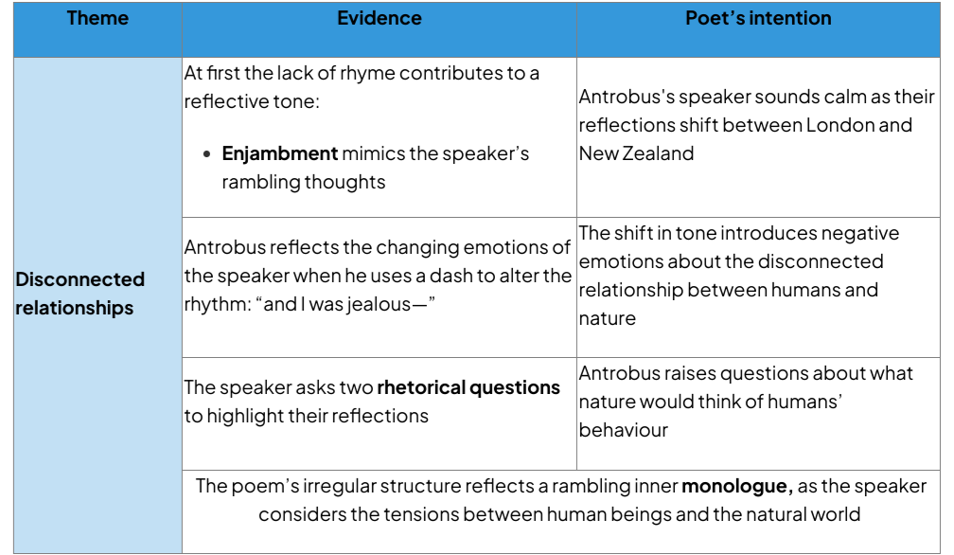

Key Language Analysis Quotations:
1.Spoons slam, steam rises.​
I catch the eye of a man​
​
sitting in the corner​
of the cafe reading alone
2.blaring so loudly​
I had to turn off my hearing aids.​
​
When all sound disappeared, I was tuned​
into a silence that was not an absence.​
3.I wondered what the trees would say about us?​
​
What books would they write if they had to cut us down?​
4.who said with birds you’re never lonely.​
In that moment I felt sorry​
​
for any grey tree in London,​
for the family they don’t have,​

Helpful Revision Links:
https://youtu.be/13Y1Vot7KEc?si=PHvlP3IyHnj2x4c7 Revision Video

Cluster Four: Change and Power

In this cluster, the poems explore a society and world that is changing in some aspects but not in others. These poems consider how environments are affecting feelings of alienation and belonging which the speakers have, as well as considering to what extent the speakers themselves have power. They also consider ideas of oppression and subjugation, considering how those who lack privilege in society can still exist in a world that restricts personal freedoms.

Comparative Questions to consider for this cluster:
- How does the passage of time affect change? And is it always in a positive way?
- To what extent do the speakers feel powerful or powerless?
- What do the speakers do within their poems to cope with change or feelings of powerlessness?

1.In a London Drawing Room by George Eliot

The sky is cloudy, yellowed by the smoke.​
For view there are the houses opposite​
Cutting the sky with one long line of wall​
Like solid fog: far as the eye can stretch​
Monotony of surface & of form​
Without a break to hang a guess upon.​
No bird can make a shadow as it flies,​
For all is shadow, as in ways o'erhung​
By thickest canvass, where the golden rays​
Are clothed in hemp. No figure lingering​
Pauses to feed the hunger of the eye​
Or rеst a little on the lap of life.​
All hurry on & look upon thе ground,​
Or glance unmarking at the passers by​
The wheels are hurrying too, cabs, carriages​
All closed, in multiplied identity.​
The world seems one huge prison-house & court​
Where men are punished at the slightest cost,​
With lowest rate of colour, warmth & joy.​
​
Glossary:
- Hemp- a type of thick material.
- Cabs- horse and carts
- Canvas- a sheet of thick material
- Monotony- always the same

Summary:
Sitting in a London drawing room, a speaker looks outside the window, criticising the way that industrialisation has changed the landscape of the environment, robbing it of colour, shape and any joy.

Key Context:
- George Eliot was the pen name of the Victorian novelist and poet Mary Ann Evans. ​
- She grew up in a rural area, but wrote this poem in 1869 whilst living in London. ​Eliot’s move from her childhood home in rural England to London could, arguably, have led her to comment on the absence of nature in the poem

- The poem was not published until 1959, 79 years after her death. ​
- Eliot was inspired by Romanticism.
- The poem criticises her society:This may be a reflection of the limitations she herself felt

Form and Structure:
- Form- written in one stanza of blank verse- unrhyming iambic pentameter. This creates a monotony in the form to reflect the city.
- Caesura reflecting the restriction and ‘wall’ of the city.
- Eliot’s poem is long and continuous in order to present urban London as relentlessly busy and dull
- Eliot’s poem “In a London Drawing Room” uses its structure to mirror the repetitive nature of London life. The lack of rhyme indicates, perhaps, the lack of joy or imagination in the city.

Key Language Analysis Quotations:
1.For view there are the houses opposite​/Cutting the sky with one long line of wall​
Like solid fog
2.No bird can make a shadow as it flies,​/For all is shadow, as in ways o'erhung​
By thickest canvass
3.All closed, in multiplied identity.​/The world seems one huge prison-house & court​

Helpful Revision Links:
https://youtu.be/FofhNR0WCIc?si=uat-t3CMWrqPQGVb First Rate Tutors Analysis
https://www.thenational.academy/pupils/programmes/english-secondary-year-10-aqa/units/poetry-anthology-first-study-199/lessons/understanding-the-poem-in-a-london-drawingroom/overview Oak Academy Intro
https://www.thenational.academy/pupils/programmes/english-secondary-year-10-aqa/units/poetry-anthology-first-study-199/lessons/analysing-the-poem-in-a-london-drawingroom/overview Oak Academy Analysis

- Like An Heiress by Grace Nichols

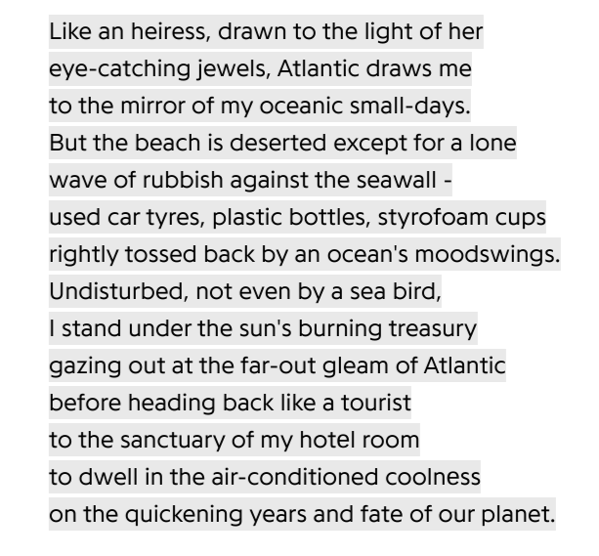

Glossary:
- Heiress- a term to describe a woman who inherits something (passed onto her). This could be a title, land, property or possessions.
- Styrofoam: a form of plastic material. Fragile and soft.
- Sanctuary: a safe place

Summary:
It is a nostalgic poem in which a speaker comes to terms with disconnected memories of childhood and a recent trip back to their homeland. The poem conveys the impact of a tainted natural world on an individual’s inner life.

Key Context:
- Grace Nichols began her life in a village on the coast in Guyana:In the poem, “Like an Heiress”, Nichol reflects on her heritage: her “oceanic small days” . In 1958, when she was eight, she and her family moved to the capital, Georgetown.
- In 1977, Nichols moved to Britain with her husband, John Agard
- “Like An Heiress” was published in her 2020 collection, Passport to Here and There:Her poetry explores multiculturalism, focusing on individuals with more than one culture:In “Like an Heiress” Nichols describes being “drawn” back to her home

Form and Structure:
- The poem’s sonnet form presents the love the narrator feels for the Atlantic Ocean. However, Nichols's unrhymed and irregular lines destabilise (shake up)the traditional rhythm.
- The poem is a Petrarchan sonnet but has fourteen unbroken lines:Without a typically separated octave and sestet, Nichols's poem subverts tradition, The sonnet form presents Nichols's idea of inheritance and heritageHowever, Nichols deviates from this to convey changes in the modern worl
- Nichols's ambiguous volta may shift the tone of the speaker at line 4 or line 8:Line 4 begins “But the beach is deserted”, signifying a move from a memory to the present tenseLine 8 shifts back to deep reflection: “Undisturbed, not even by a seabird”
- The poem alternates from a narrator’s memory to their current observations and, finally, to deep reflection:This reflects the contrast between the Atlantic Ocean of the past and its current condition.
- Nichols presents an individual’s bond with the legacy of the natural world becoming unstable.
- The poem, “Like an Heiress” uses free verse first-person perspective to present a reflective voice:Nichols shifts to first-person plural at the end of the poem to present a personal warning about “the fate of our planet”
- Lack of rhyme contributes to the narrator’s emotional and free flowing monologue:However, the narrator includes readers in their reflection to suggest the world’s legacy belongs to all

Key Language Analysis Key Quotations:
1.Like an heiress, drawn to the light of her/eye-catching jewels, Atlantic draws me/ to the mirror of my oceanic small-days
2.used car tyres, plastic bottles, styrofoam cups - /rightly tossed back by an ocean's moodswings.
3.to dwell in the air-conditioned coolnеss/on the quickening years and fate of our planet

Helpful Revision Links:
https://youtu.be/n-jPdR7P1mw?si=-X3es9lJHfThFHNJ Nichols reading the poem
https://youtu.be/EhZ5mFURngA?si=KDM2xJ_axNDnwidy Analysis video

3. A Century Later by Imitiaz Dharker

The school-bell is a call to battle,​
every step to class, a step into the firing-line.​
Here is the target, fine skin at the temple,​
cheek still rounded from being fifteen.​
​
Surrendered, surrounded, she​
takes the bullet in the head​
​
and walks on. The missile cuts​
a pathway in her mind, to an orchard​
in full bloom, a field humming under the sun,​
its lap open and full of poppies.​
​
This girl has won​
the right to be ordinary,​
​
wear bangles to a wedding, paint hеr fingernails,​
go to school. Bullet, she says, you arе stupid.​
You have failed. You cannot kill a book​
or the buzzing in it.​
​
A murmur, a swarm. Behind her, one by one,​
the schoolgirls are standing up​
to take their places on the front line.​

Glossary:
Orchard: a place where fruit grows
Murmur: talking under your breath

Summary:
​​The speaker describes the experience of a young girl as she shows determination to attend school, despite the conflict surrounding her. The girl is shot in the head but refuses to yield and continues to advocate for the rights to education for all.

Key Context:
- Imtiaz Dharker was born in Pakistan in 1954. She was raised in Glasgow and now lives in Britain and India. ​
- She often writes about identity and human strength over adversity. ​
- This particular poem was published in 2014 and was a response to ‘Anthem for Doomed Youth’ (100 years later) and the attack on Malala Yousafzai.​
- The poem focuses particularly on the idea of girls who face opposition when going to school:
  - It draws on allusions to a young girl named Malala Yousafzai
  - In 2012, she was shot in the head by the Taliban in Pakistan, Dharker’s birthplace
  - Malala survived and became an activist for the education of women
Form and Structure:
- The poem is written in free verse. It alternates between quatrains and couplets. This could reflect the chaos of her battle.​
- The poem begins with the experience of one school girl- this shifts to a collective effort by the end of the poem. ​
- The poem features caesura several times, this could highlight the disruption to education caused by conflict ​
- The poem also features enjambment, this continuation could build momentum and reflect the girls resilience and the creation of a campaign (more people joining)

Key Language Analysis Quotations:
1.The school-bell is a call to battle,​
Every step to class, a step into the firing-line.
2.The missile cuts a pathway in her mind, to an orchard in full bloom,
3.A murmur, a swarm. Behind her, one by one, the schoolgirls are standing up

Helpful Revision Links:
https://youtu.be/5KbpgXA4JBk?si=6wWT-aYudNg-cMoc Revision Video
https://www.thenational.academy/pupils/programmes/english-secondary-year-10-aqa/units/poetry-anthology-first-study-199/lessons/understanding-the-poem-a-century-later-o2430/overview Oak Academy Intro
https://www.thenational.academy/pupils/programmes/english-secondary-year-10-aqa/units/poetry-anthology-first-study-199/lessons/analysing-the-poem-a-century-later/overview Oak Academy Analysis

4. Thirteen by Caleb Femi

You will be four minutes from home​
when you are cornered by an officer​
who will tell you of a robbery, forty​
minutes ago in the area. You fit​
the description of a man? – You’ll laugh.​
Thirteen, you’ll tell him: you’re thirteen.​
​
You’ll be patted on the shoulder, then, by another fed​
whose face takes you back to Gloucester Primary School,​
a Wednesday assembly about being little stars.​
This same officer had an horizon in the east​
of his smile when he told your class that​
you were all supernovas,​
the biggest and brightest stars.​
​
You will show the warmth of your teeth​
praying he remembers the heat of your supernova;​
he will see you powerless – plump.​
You will watch the two men cast lots for your organs.​
​
Don’t you remember me? you will ask.​
You gave a talk at my primary school.​
While fear condenses on your lips,​
you will remember that Wednesday, after the assembly,​
your teacher speaking more about supernovas:​
how they are, in fact, dying stars​
on the verge of becoming black holes.​

Glossary:
Powerless- without ability, influence or power. ​
Supernova- a star that suddenly increases in brightness.

Summary:
The poem Thirteen is about a young Black boy being stopped by the police. It tells the story of a young boy who is four minutes away from home when he is stopped by two police officers. They say he fits the description of a man who has just committed a robbery in the area. The boy laughs and tells them that he is only 13 years old. The boy remembers the officers from a school visit and tries to hide his fear from them.

Key Context:
- Thirteen is based on a real experience that Femi had when he was 13 years old.Reflecting on the experience in an interview, Femi has said: “What was really striking about that moment for me was this sense of not being afforded the privilege – not even the privilege, the fact – of being a kid.”
- Caleb Femi was born in Nigeria in 1990. He emigrated to the UK at the age of seven and lived on London’s North Peckham Estate, which is the inspiration for his debut collection of poetry and photography, Poor (2020).​
- The estate was the scene of ten-year-old Damilola Taylor’s racially-aggravated stabbing in 2000. Taylor was walking home from the library when he was killed and Femi recognises a kindred spirit.​
- A love of garage and grime music germinated into a love of language and Femi taught English at a Tottenham comprehensive until he realised that the syllabus was stifling his students.​
- He instead saw poetry as a means to help young people find a voice and from 2016 to 2018 served as London’s first Young People’s Laureate.​
​
Form and Structure:
- The poem’s conversational form creates a casual tone to represent both the individual’s identity and a sense of their bravado in the face of everyday experiences that reduce their identity.
- Femi uses free verse to bring the speaker’s story to life: Beginning in the middle of a story creates confusion: “You will be four minutes from home/when you are cornered by an officer”The irregular form contributes to a narrative style that reflects instability in the individual’s life
- Femi uses a second-person address:This presents the boy’s attempt at confidence: “You’ll laugh.”
- The conversational, casual voice of a thirteen-year-old speaker reflects an initial attempt at bravado:It also has the effect of placing a listener in the speaker’s shoes
- Femi uses colloquial language to create an informal tone: “another fed”. This is reflective of the boy’s language and identityIt may also imply a poor relationship with the police in the community.
- Femi’s poem manipulates rhythm to present a dramatic and emotional story that portrays the vulnerability of a young boy in his uncertain world.
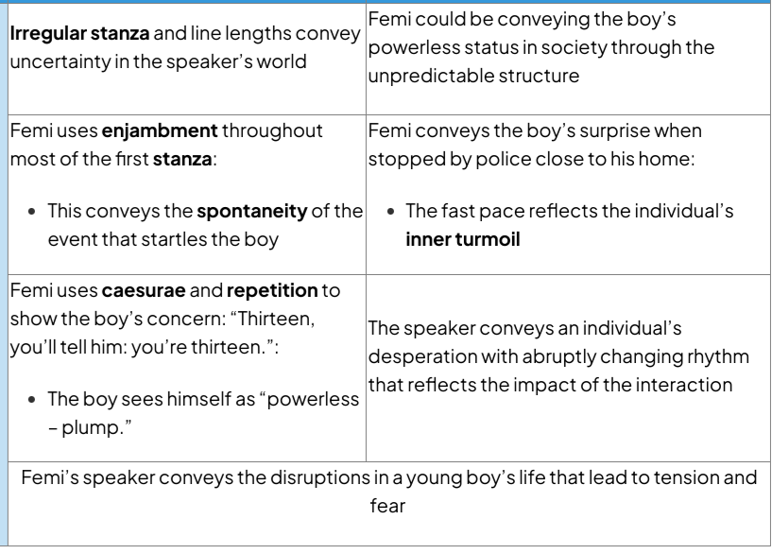
Key Language Analysis Quotations:
- “You will be four minutes from home/when you are cornered by an officer/who will tell you of a robbery, forty/minutes ago in the area. You fit”
- This same officer had an horizon in the east/ of his smile when he told your class that/ you were all supernovas,
- Don’t you remember me? you will ask./You gave a talk at my primary school./While fear condenses on your lips,
- your teacher speaking more about supernovas:/how they are, in fact, dying stars on the verge of becoming black holes.

Helpful Revision Links:
- https://www.thenational.academy/pupils/programmes/english-secondary-year-10-aqa/units/poetry-anthology-first-study-199/lessons/understanding-the-poem-thirteen-s2439/overview Oak Academy Intro
- https://www.thenational.academy/pupils/programmes/english-secondary-year-10-aqa/units/poetry-anthology-first-study-199/lessons/analysing-the-poem-thirteen-v2440/overview Oak Academy Analysis
- https://www.youtube.com/watch?v=a9W3zYExQQw Mr King analysis

Example Questions

- Compare and contrast the presentation of identity in ‘Homing’ and one other poem from the ‘Worlds and Lives’ anthology.
- Compare and contrast the presentation of isolation in ‘Name Journeys’ and one other poem from the ‘Worlds and Lives’ anthology.
- Compare and contrast the presentation of heritage in ‘The Jewelery Maker’’ and one other poem from the ‘Worlds and Lives’ anthology.
- Compare and contrast the presentation of the past in ’A Wider View’ and one other poem from the ‘Worlds and Lives’ anthology.
- Compare and contrast the presentation of alienation in ‘pot’ and one other poem from the ‘Worlds and Lives’ anthology.
- Compare and contrast the presentation of relationships with others in ‘On An Afternoon Train from Purley to Victoria’ and one other poem from the ‘Worlds and Lives’ anthology.
- Compare and contrast the presentation of conflict in ‘Portable Paradise’ and one other poem from the ‘Worlds and Lives’ anthology.
- Compare and contrast the presentation of peace in ’Lines Written in Early Spring’ and one other poem from the ‘Worlds and Lives’ anthology.
- Compare and contrast the presentation of human’s relationship with nature in ‘Shall Earth No More Inspire Thee’ and one other poem from the ‘Worlds and Lives’ anthology.
- Compare and contrast the presentation of connection in ‘With Birds You’re Never Lonely’ and one other poem from the ‘Worlds and Lives’ anthology.
- Compare and contrast the presentation of desire for change in ‘England in 1819’ and one other poem from the ‘Worlds and Lives’ anthology.
- Compare and contrast the presentation of the impact of change in ‘In a London Drawing Room’ and one other poem from the ‘Worlds and Lives’ anthology.
- Compare and contrast the presentation of the impact of humans in ‘Like an Heiress’ and one other poem from the ‘Worlds and Lives’ anthology.
- Compare and contrast the presentation of change in ‘A Century Later’ and one other poem from the ‘Worlds and Lives’ anthology.
- Compare and contrast the presentation of society in ‘Thirtee’ and one other poem from the ‘Worlds and Lives’ anthology.

