GCSE revision support

Top Tips for Exam Revision
- Don’t leave it until the last minute
Start your revision early! This gives you time to make sure you cover all the topics you need and to practise, reflect and improve.
- Use a revision timetable
Plan your time effectively to get the most out of your revision session. Ticking off each topic will also help you keep track of your exam preparation.
- Practise, practise, practise!
Use past papers, examiner reports and other practice material to help you reinforce your learning and understanding.
- Take breaks
Make sure you take regular breaks during revision – it will help you to stay focused and committed.
- Avoid using your phone
Messages, apps and social media can all act as a distraction. Make sure you put your phone away so you can focus on your revision. You can use your settings to stop you from accessing certain apps for a set period of time.

Top Tips for Effective Revision Breaks
- Get away from your revision space.
It’s really easy to spend both your revision time and break in the same place. Find a reason to go into a different room or even go for a short walk. This will help you to distinguish between your revision and your break effectively, so your mind relaxes.
- Have something to eat and drink.
It’s really important you stay hydrated and fuelled during your revision and exams. Your brain (and body!) needs enough energy to maintain focus.
- Avoid napping
It can be really tempting to have a nap during a break – your eyes may well feel heavy from focusing on text. However, a nap can leave you feeling groggy, making you lack energy in your next lot of revision.
- Exercise
You usually do your revision sat down. Use your break to stand up, stretch or even go for a short walk.
- Stick to your revision timetable/schedule
Make sure you know how long your break is going to be for. Resist the temptation to say, ‘I’ll get back to it in a minute’ as this can easily turn into an entire afternoon! You’ll be able to enjoy your breaks more if you aren’t feeling guilty about the work you should be doing.

Snacks and hydration
It’s incredibly important to stay hydrated and fuelled during exams and revision - your body and brain need energy to maintain focus. However, certain foods are better than others to keep you energised.
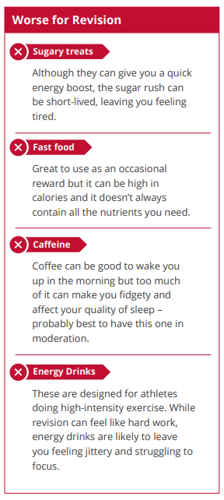
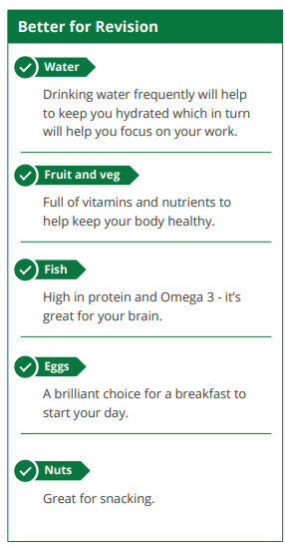

How to start revision
One of the most important things about revision is making sure you’re using your time efficiently. That means using effective revision techniques, and making sure the techniques you’re using work for you. Like any other skill, revision needs practice, so don’t leave it until the last minute! Here are ten tips to get you off to a good start.

Read the examiners’ report
If you want to get an idea of what examiners are looking for, or common mistakes, find the examiners’ reports for the exam in the previous year. This might help focus your work and practice on certain skills and questions.

Check past papers
Past papers are a great way of getting used to the type of questions you’ll see in the exam and how the questions are worded. However, it’s important that you reflect and review your work on past papers, for example, make sure you target specific topics which you may struggle with – don’t just pick the questions you can already do! You might want to combine your work on past papers with the examiners’ reports to see how you can improve your answers.

Be prepared
It may seem obvious but make sure you cover all the topics. If you’re unsure of what might come up in an exam, ask your teacher/tutor for a checklist. Manage your time effectively so you don’t spend too long on one particular topic yet have enough time to go over everything and not just gloss over it.

Plan!
Revision can feel very overwhelming – where do you begin with so many topics to cover? It might seem like an impossible task. Breaking subjects down into smaller, more achievable chunks will make your revision more manageable. Use these in your revision planning – the sense of achievement from being able to tick these off is a great motivation.

Revise continually
Don’t be tempted to cram and leave things to the last minute – you won’t actually retain all the information and you might cause yourself unnecessary stress. Get into the habit of doing a little bit of revision nightly or weekly throughout the year. By the time exam season comes around, you will have more time to practise questions rather than having to learn lots of new topics.

Highlight the right way
While highlighting can make your work look really colourful, it’s important you are highlighting effectively. Highlighters are a great way to emphasise key words, but try not to highlight large amounts of text. You can use different colour highlighters to show links between separate pieces of information. This will help you when you’re trying to recall the key points in an exam. Consider using a mind-map as well to help structure your ideas.

Don’t just read!
Be sure to make brief notes on what you have read. Either write down your notes or record your thoughts and listen back to them.

Avoid copying full sentences
Summarise the main points in note form. Lots of detail can be great but it can also make reading back through the notes time-consuming and a little overwhelming. Include the most relevant bits of information in bullet points to help structure your notes, so you can get to the points quicker when reading them back.

Use a bit of colour
Try writing your notes using different colours. Studies have shown that, for some people, it can make a difference in remembering information if notes are written down in blue ink instead of black ink! Writing notes for every subject in the same colour can make it difficult for it to stand out. That said, make sure you focus on your revision and not just making notes look good!

Practise technique
It’s really easy to focus on the content when revising. However, equally as important is actually understanding how to achieve the exam criteria. Mark yourself using an actual mark scheme so you can see the kind of things examiners look for and apply it to future answers.

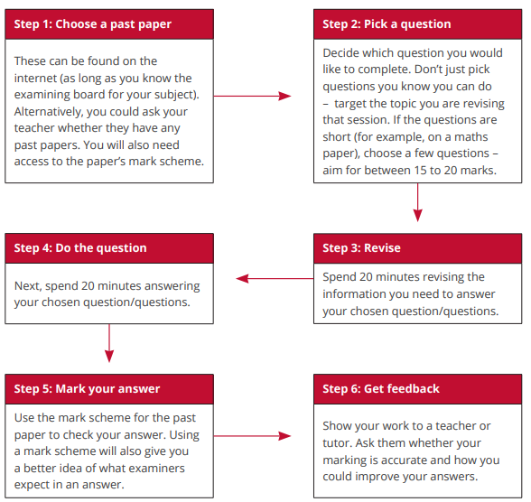
How to structure an hour of revision

Useful websites
- https://corbettmaths.com/
- https://www.mathsgenie.co.uk/gcse.html
- https://mmerevise.co.uk/gcse-maths-revision/#revise
- https://www.thenational.academy/teachers/key-stages/ks4/subjects/maths/programmes
- https://mathsbot.com/
- https://www.onmaths.com/
- https://mathsupgrade.co.uk/index.html
- https://www.resourceaholic.com/
- https://mathskitchen.com/revision/gcse-maths
- https://maths4everyone.com/index.php
- https://www.draustinmaths.com/
- https://www.1stclassmaths.com/edexcelrevision
- https://www.thenational.academy/teachers/key-stages/ks4/subjects/maths/programmes

Useful YouTube channels
If you find any other useful channels let me know.
- Science and Maths by Primrose Kitten
- The Organic Chemistry Tutor
- Eddie Woo
- Tecmath
- NancyPi
- Corbett Maths
- Cognito
- 1st Class maths
- The GCSE Maths Tutor
- AlphaMath
- JensenMath
- Hunger4Math
- TLMaths

Good luck!
You’ve got this!
Hard work pays off.
Relax.
Breathe.
Trust in your own ability.
Remember your equipment.
Check your work.
Do your best!
Never give up!
A problem is a solution waiting to be found.
Keep calm.

