Finham Park 2

Key Stage 4 English

Year 10

Summer Exam Preparation Booklet

NAME: _______________________________________
TEACHER: ___________________________________



- This booklet will help you revise and prepare thoroughly for your English exam.
- This revision booklet contains tasks that require you to practise key skills needed for the English language examination.
- The first part of the booklet requires you to RAG rate the skills that you will be required to use in the exam (see instructions on that page).
- Attempt every question.
- Take your time on the writing tasks and make sure that you read through your work regularly.
- If you do get stuck, look for this symbol: or ask your teacher for help.
- Try your absolute best!
Reading Tasks |  | Tick off which tasks you have completed. | Writing Tasks
Task 1 Question 1 & 2:  Retrieval and language analysis |  | Tick off which tasks you have completed. | Task 4 Question 5:  Creative Writing Plan.
Task 2 Question 3: Structure |  | Tick off which tasks you have completed. | Task 5 Question 5:  Opening Paragraph
Task 3 Question 4: Evaluate Methods |  | Tick off which tasks you have completed. | Task 6 Question 5:  Creative Writing

Self-Assessment
Before you begin the activities in this booklet, rate yourself against the areas below.

Skill | RAG Rating  (Circle or shade how confident you are)  R = Red (not confident at all)  A = Amber (not very confident)  G = Green (really confident) |  |  | How do you plan on improving your confidence?
Reading comprehension | R | A | G
Inference | R | A | G
Language Analysis | R | A | G
Evaluation | R | A | G
Creative Writing | R | A | G
SPAG | R | A | G
Final Evaluation
Once you have completed the booklet, refer back to this table; it will help you to see what skills you have improved on; where your confidence has grown and what areas you still need to work on.
Use it to help you complete your final reflection (final page).

Task One: Reading for Understanding
You will receive one source with your exam paper; it will be an extract taken from a novel published in the 20th or 21st century. Questions 1 to 4 (the Reading section) will be based around this extract.
Before you start reading the source, you must read the context box at the top of the page. This will give you some relevant information about the source to aid your understanding: the text it came from, any characters within the extract, when it is set/ was published etc.
DO NOT include any quotations from this box in any of your answers – it is not officially part of the source.

Source A: Alex Cold lives with his parents and two younger sisters, Andrea and Nicole, in a small American town, but when his mother becomes ill, family life changes beyond recognition.

in 2002 by Jay Rayner
Alexander Cold awakened at dawn, startled by a nightmare. He had been dreaming that an enormous black bird had crashed against the window with a clatter of shattered glass, flown into the house, and carried off his mother. In the dream, he had watched helplessly as it clasped her clothing in its yellow claws, flew out the same broken window, and disappeared into a sky heavy with dark clouds.
What had awakened him was the noise from the storm: wind lashing the trees, rain on the rooftop, and thunder. He turned on the light with a sensation of being adrift in a boat, and pushed closer to the bulk of the large dog sleeping beside him. He pictured the roaring Pacific Ocean a few blocks from his house, spilling in furious waves against the rocks. He lay listening to the storm and thinking about the black bird and about his mother, waiting for the pounding in his chest to die down. He was still tangled in the images of his bad dream.
Alexander looked at the clock: 6.30, time to get up. Outside, it was beginning to get light. He decided that this was going to be a terrible day, one of those days when it’s best to stay in bed because everything is going to turn out bad. There had been a lot of days like that since his mother got sick; sometimes the air in the house felt heavy, like being at the bottom of the sea.
At breakfast Alex was not in the mood to applaud his father’s efforts at making pancakes. His father was not exactly a good cook; the only thing he knew how to do was pancakes, and they always turned out like rubber-tyre tortillas. His children didn’t want to hurt his feelings, so they pretended to eat them, but any time he wasn’t looking, they spit them out.
‘When’s Momma going to get better?’ Nicole asked, trying to spear a rubbery pancake with her fork.
‘Shut up, Nicole,’ Alex replied.
‘Momma’s going to die,’ Andrea added.
‘Liar! She’s not going to die!’ shrieked Nicole.
‘You two are just kids. You don’t know what you’re talking about!’ Alex exclaimed.
‘Here, girls. Quiet now. Momma is going to get better,’ his father interrupted, without much conviction.
Alex was angry with his father, his sisters, life in general – even with his mother for getting sick. He rushed out of the kitchen, ready to leave without breakfast.
Except for his father’s pancakes and an occasional tuna-and-mayonnaise sandwich, no one in the family had cooked for months. There was nothing in the refrigerator but orange juice, milk and ice cream; at night they ordered in pizza or Chinese food. At first it was almost like a party, because each of them ate whenever and whatever they pleased, mainly sweets, but by now everyone missed the balanced diet of normal times.
Alex had realised during those months how enormous their mother’s presence had been and how painful her absence was now. He missed her easy laughter and her affection, even her discipline. She was stricter than his father, and sharper. It was impossible to fool her; she could see the unseeable. He missed her music, her flowers, the once-familiar fragrance of fresh-baked cookies, and the smell of paint. It used to be that his mother could work several hours in her studio, keep the house immaculate, and still welcome her children after school with cookies. Now she barely got out of bed to walk through the rooms with a confused air, as if she didn’t recognise anything; she was too thin, and her sunken eyes were circled with shadows. Her canvases, which once were explosions of colour, sat forgotten on their easels, and her oil paints dried in their tubes. His mother seemed to have shrunk; she was little more than a silent ghost.
Reflection
Summarise what you have just read into 6 main points.
- _______________________________________________________________________________________________________
- ________________________________________________________________________________________________________
- ________________________________________________________________________________________________________
- _______________________________________________________________________________________________________
- _______________________________________________________________________________________________________
- _______________________________________________________________________________________________________

Extra notes on the source:

Task One: Retrieval and Language Analysis
Question 1: Read again Source A Lines 1 – 5.
List four things about the bird in Alex’s nightmare.

- _______________________________________________________________________________________________________
- ________________________________________________________________________________________________________
- ________________________________________________________________________________________________________
- _______________________________________________________________________________________________________
4 marks
5 mins
- Re-read the text to find the answers
- Double check them using the text
- Quote directly from the source

Question 2: Language. Look in detail at this extract from lines 6 to 11 of the source:
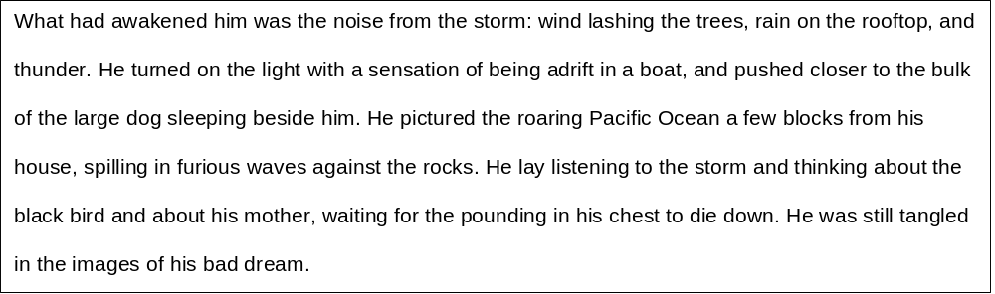
Question 2: How does the writer use language here to describe the effects of the storm?
You could include the writer’s choice of:
- words and phrases
- language features and techniques
- sentence forms.

- Read the focus of the question carefully - it could be in relation to character, setting, atmosphere or idea, and highlight the key words in the question.
- Next, read through the extract and identify the magic 3 (interesting noun phrases/verbs/language techniques) that are relevant to the focus of your question.
- Be selective with your quotes. Which quotation can you analyse in more depth? Which quotation offers you a more perceptive interpretation?
- Annotate your chosen quotations by zooming in on key words and explain the effect on you the reader
- Write 2 – 3 paragraphs

Point/quote/effect

The writer describes the storm as ‘_________________’
This suggests ____________________________________________________________________________________________________________________________________________________
However, the author of Source B explains: “_____________________________________” which implies that ______________________________________________________________________________________________________________________________________________________________________________________________________________________________
In addition

8 marks
10 mins

2 paragraphs
Question 2:
PEZAL
The writer uses … / The writer describes ….
Quote
The key word …. Implies / suggests …
This makes me F/ I / T ….
Additionally / Alternatively …
Thus …

Reflection
WWW:_____________________________________________________________________________________________________________________
_____________________________________________________________________________________________________________________________
EBI: _______________________________________________________________________________________________________________________
___________________________________________________________________________________________________________________________
Task Two: Analysing Structure

Question Three: You need to think about the whole of source.
This is the opening of a novel. How has the writer structured the text to interest you as a reader?
You could write about:
- What the writer focuses your attention on at the beginning
- How and why the writer changes this focus as the Source develops
- Any other structural features that interest you.

As with language ask yourself the Magic 3 Questions:
- Who is talking?
- What time is it?
- What are the patterns?
Question Three:
At the beginning the writer focuses the reader on … QUOTE The use of …. Makes me F/I/T …
The writer then shifts our focus to …. QUOTE The use of … Makes me F/I/T ….
At the end are attention is drawn to …. QUOTE The use of …. Makes me F/I/T ….

8 marks
10 mins
3 paragraphs: Beginning, Middle and End

Reflection
WWW:_____________________________________________________________________________________________________________________
_____________________________________________________________________________________________________________________________
EBI: _______________________________________________________________________________________________________________________
___________________________________________________________________________________________________________________________

Question Four: Focus this part of your answer on the second half of the source from line 16 to the end.
A student said ‘This part of the story, set during breakfast time, shows that Alex is struggling to cope with his mother’s illness.’
To what extent do you agree?
In your response, you could:
- consider your own impressions of Alex
- evaluate how the writer shows that Alex is struggling to cope
- support your response with references to the text

Point: why you agree / disagree with the statement. | - I completely / partially agree/disagree with the statement because…
EVIDENCE: Select a quote to justify your opinion. | - This is evident / when the writer states…
Zoom: Zoom in on all relevant key words / phrases, identify language features and explain what they suggest about Alex. | - The [insert language feature + key word/phrase] shows….  - which implies…  - Furthermore / In addition,
Analyse: Explain WHY this quote makes you agree / disagree with the statement – what does it make you Think/feel/imagine/question about Alex? | - This idea is reinforced later in the text when...  - The [insert language feature + key word/phrase] shows…  - which suggests…  - Furthermore / In addition
LINK: Select a second quotation which supports your opinion and analyse as above | - This makes me as a reader...

Task Three: Evaluate Writer’s Methods

16 marks
20 mins
4 paragraphs
- Link your opinion to the statement
- chosen quotes to prove your point!
- Analyse the effect of the quotes. Say how and why they make you agree/disagree with the statement.

A way to plan:
What things I should compare | Source A | Source B
Question Four
Question 4:
Reflection
WWW: ___________________________________________________________________________________________
____________________________________________________________________________________________________
EBI: _______________________________________________________________________________________________

Task Four: Creative Writing Plan

Task Four: Creative Writing Plan:

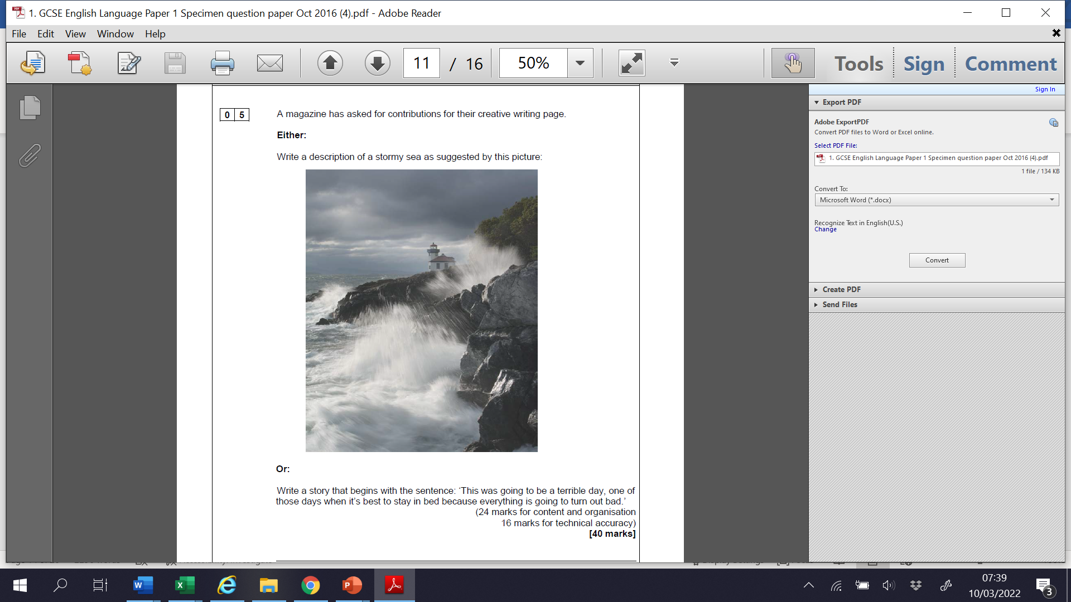

Spelling, punctuation and grammar (16)
- Separate sentences that make sense
- Varied sentence structures
- Standard English
- A range of accurate punctuation
- Accurate spelling
Content and Organisation (24 marks)
- Achieve the purpose of writing
- Paragraphing
- Linked ideas
- Ambitious vocabulary
- Use of techniques for effect

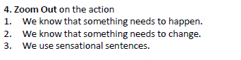
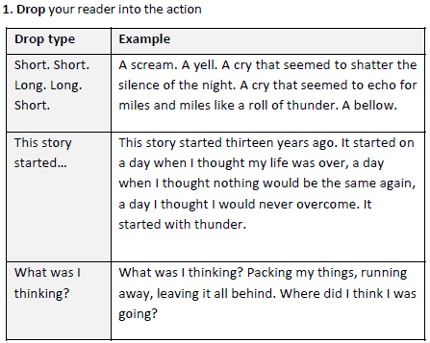
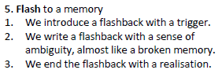
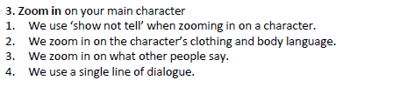
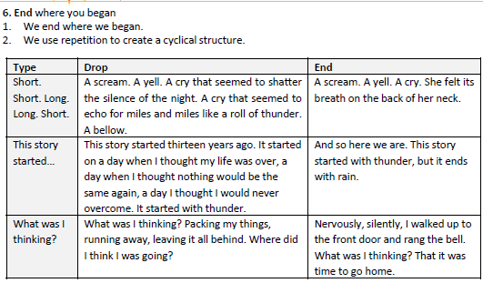
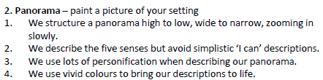

Plan

Task Five: Write your opening paragraph

Task Five: Opening Paragraph

Task 6: Complete your creative writing

The skills that I feel that I have improved the most are:

Based on the RAG checklist, I can say that I am more confident with:
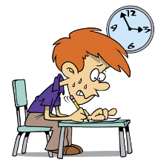

After completing this booklet, the activity that I found most helpful was:
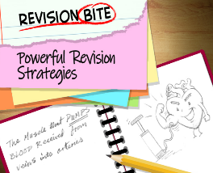

I would like more help with:
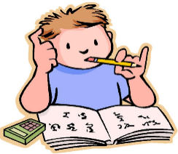

Teacher’s reflection:
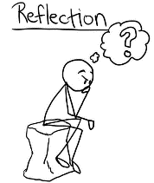

Signed:

Reflections:

