
Please write clearly in block capitals.
Centre number |  |  |  |  |  | Candidate number
Surname
Forename(s)
Candidate signat | ure

GCSE
ENGLISH LANGUAGE (NEW PRO-FORMA)
Paper 1 Explorations in creative reading and writing

Monday 5 November 2018 Morning Time allowed: 1 hour 45 minutes
Materials
For Examiner’s Use
Question | Mark
1
2
3
4
5
TOTAL

For this paper you must have:
- Source A – provided as a separate insert.

Instructions
- Answer all questions.
- Use black ink or black ball-point pen.
- Fill in the boxes at the top of this page.
- You must answer the questions in the spaces provided.
- Do not write outside the box around each page or on blank pages.
- Do all rough work in this book. Cross through any work you do not want to be marked.
- You must refer to the insert booklet provided.
- You must not use a dictionary.
Information
- The marks for questions are shown in brackets.
- The maximum mark for this paper is 80.
- There are 40 marks for Section A and 40 marks for Section B.
- You are reminded of the need for good English and clear presentation in your answers.
- You will be assessed on the quality of your reading in Section A.
- You will be assessed on the quality of your writing in Section B.
Advice
- You are advised to spend about 15 minutes reading through the source and all five questions you have to answer.
- You are advised to plan your answer to Question 5 before you start to write.
- You should make sure you leave sufficient time to check your answers.









IB/G/Nov18/E5 8700/1

0 | 1 | Section A: Reading  Answer all questions in this section.  You are advised to spend about 45 minutes on this section.  Read again the first part of the source, from lines 1 to 9.  Answer all parts of this question.  Tick (✓) one box for each question. [4 marks]
01.1 How is the jungle described?
Low and narrow
High and broad
Dark and sinister
[1 mark]
01.2 The wings of which creatures are described?
Birds
Eagles
Pterodactyls
[1 mark]
01.3 What does Travis do?
Blows his whistle
Shakes like a kid
Raises his hand
[1 mark]
01.4 What is the jungle full of?
Twitterings and rustlings
Twitterings and screeches
Creaks and groans
[1 mark]

4

0 | 2 | Look in detail at this extract, from lines 16 to 26 of the source:
It came on great oiled, resilient, striding legs. It towered thirty feet above half of the trees, a great evil god, folding its delicate watchmaker’s claws close to its oily reptilian chest. Each lower leg was a piston, a thousand pounds of white bone, sunk in thick ropes of muscle, sheathed over in a gleam of pebbled skin like the armour of a terrible warrior. Each thigh was a ton of meat, ivory, and steel mesh. And from the great breathing cage of the upper body those two delicate arms dangled out front, arms with hands which might pick up and examine men like toys, while the snake neck coiled. And the head itself, a ton of sculptured stone, lifted easily upon the sky. Its mouth gaped, exposing a fence of teeth like daggers.
Its eyes rolled, ostrich eggs, empty of all expression save hunger. It closed its mouth in a death grin. It ran, its pelvic bones crushing aside trees and bushes, its taloned feet clawing damp earth, leaving prints six inches deep wherever it settled its weight.
How does the writer use language here to describe the Tyrannosaurus Rex? You could include the writer’s choice of:
- words and phrases
- language features and techniques
- sentence forms.
 |  | [8 marks]

8

Extra space

Turn over for the next question

0 | 3 | You now need to think about the whole of the source. This text is from the middle of a short story.  How has the writer structured the text to create suspense?  You could write about:  - how suspense has increased or decreased by the end of the source  - how the writer uses structure to create an effect  - any other structural features, such as changes in mood, tone or perspective.
 |  | [8 marks]

8

Extra space

0 | 4 | Focus this part of your answer on the second part of the source, from line 31 to the end.  In this part of the source, the Tyrannosaurus Rex could be seen as terrifying and a creature that causes panic. To what extent do you agree or disagree with this statement?  In your response, you could:  - consider your impressions of the Tyrannosaurus Rex and the panic it creates  - comment on the methods the writer uses to present the T-Rex and panic caused  - support your response with references to the text.
 |  | [20 marks]

20

0 | 5 | Section B: Writing  You are advised to spend about 45 minutes on this section.  Write in full sentences.  You are reminded of the need to plan your answer.  You should leave enough time to check your work at the end.  A travel magazine is running a creative writing competition. Choose one of the options below for your entry.
Either
Write a description of life in 200 years’ time from your imagination. You may choose to use the picture provided for ideas.
 |  | 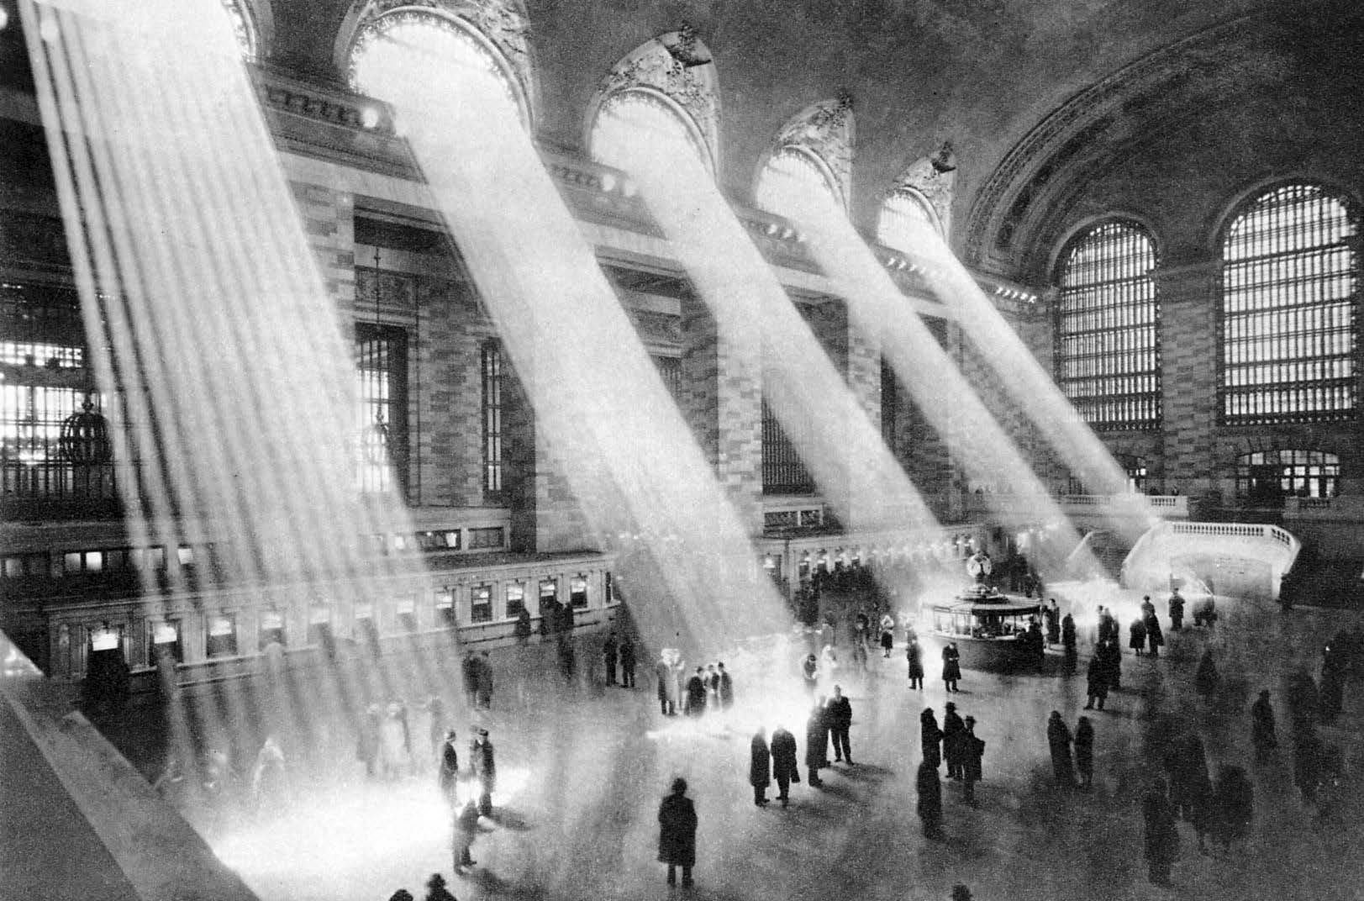
 |  | or
 |  | Write the opening of a story about time travel.
 |  | (24 marks for content and organisation 16 marks for technical accuracy)
 |  | [40 marks]

40

Extra space

END OF QUESTIONS



IB/G/Nov18/8700/1

DO NOT WRITE ON THIS PAGE ANSWER IN THE SPACES PROVIDED

Copyright information

For confidentiality purposes, from the November 2015 examination series, acknowledgements of third party copyright material will be published in a separate booklet rather than including them on the examination paper or support materials. This booklet is published after each examination series and is available for free download from www.aqa.org.uk after the live examination series.

Permission to reproduce all copyright material has been applied for. In some cases, efforts to contact copyright-holders may have been unsuccessful and AQA will be happy to rectify any omissions of acknowledgements. If you have any queries please contact the Copyright Team, AQA, Stag Hill House, Guildford, GU2 7XJ.

Copyright © 2018 AQA and its licensors. All rights reserved.

